PCA-SIMS Spectra Analysis Report

**Low P (negative ions)**

ToF-SIMS testing date: 20230810

ToF-SIMS operator: Chris Pasture

# 2D PCA scores plots

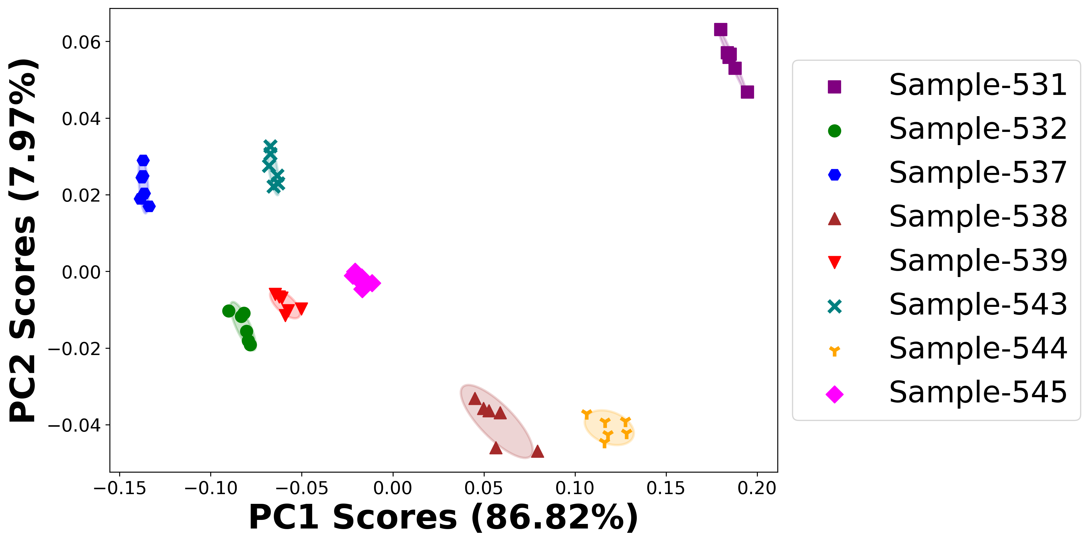

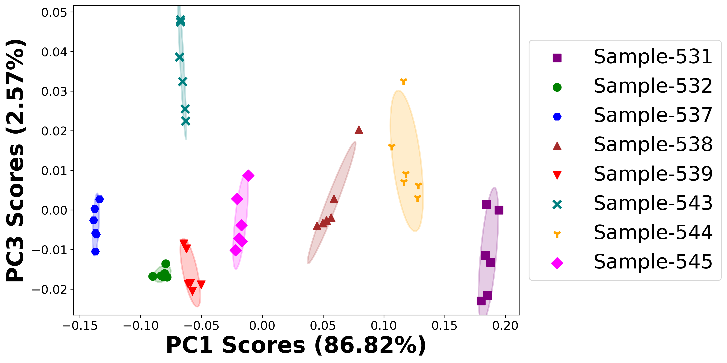

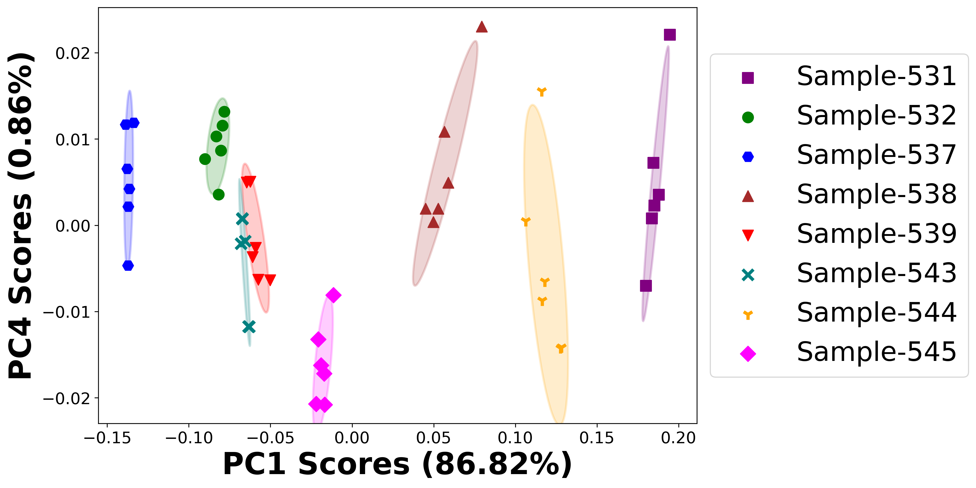

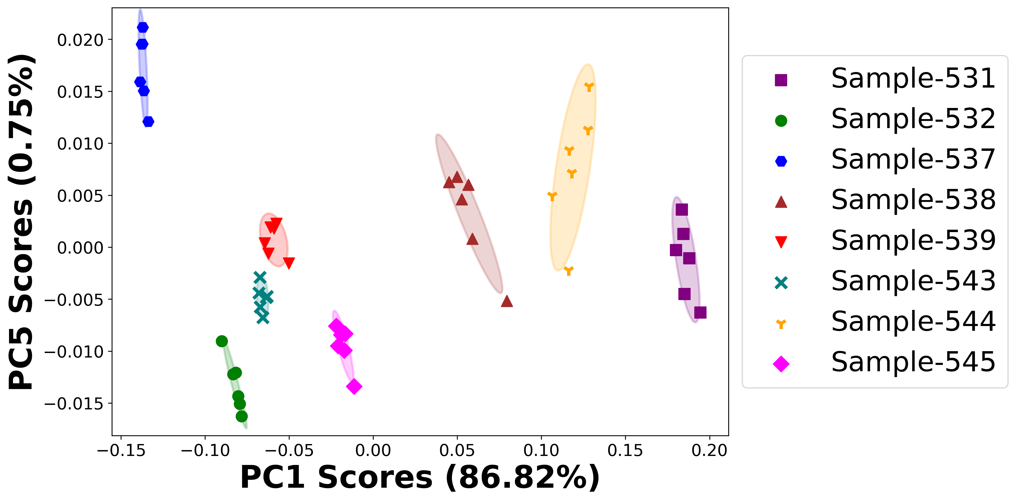

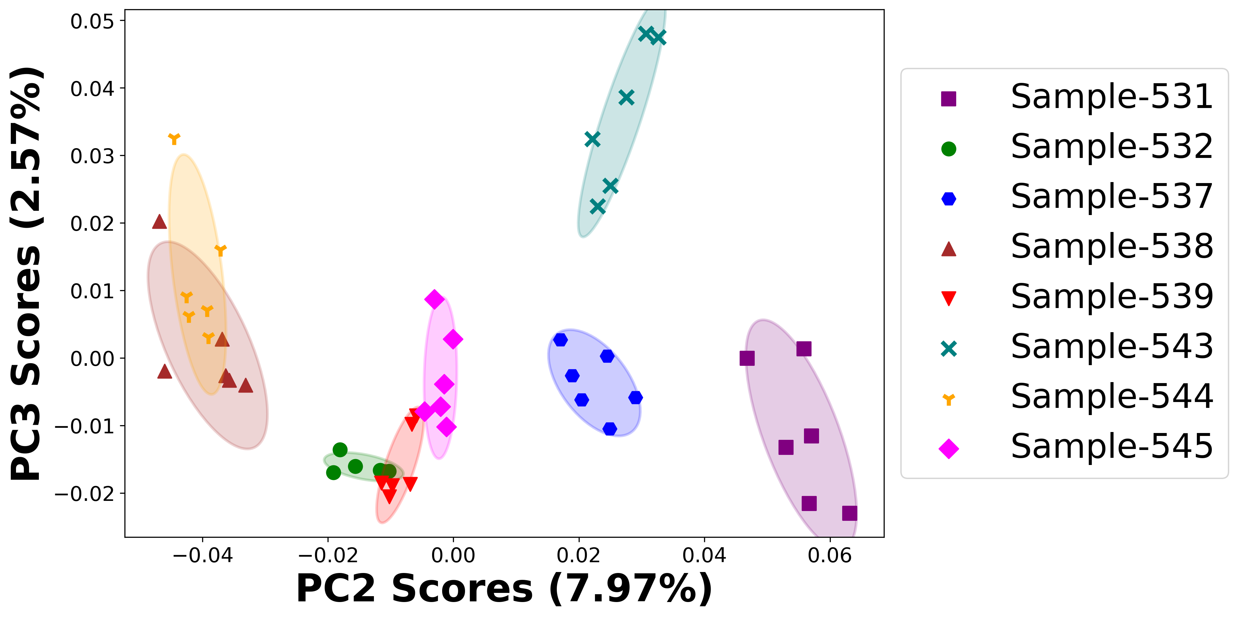

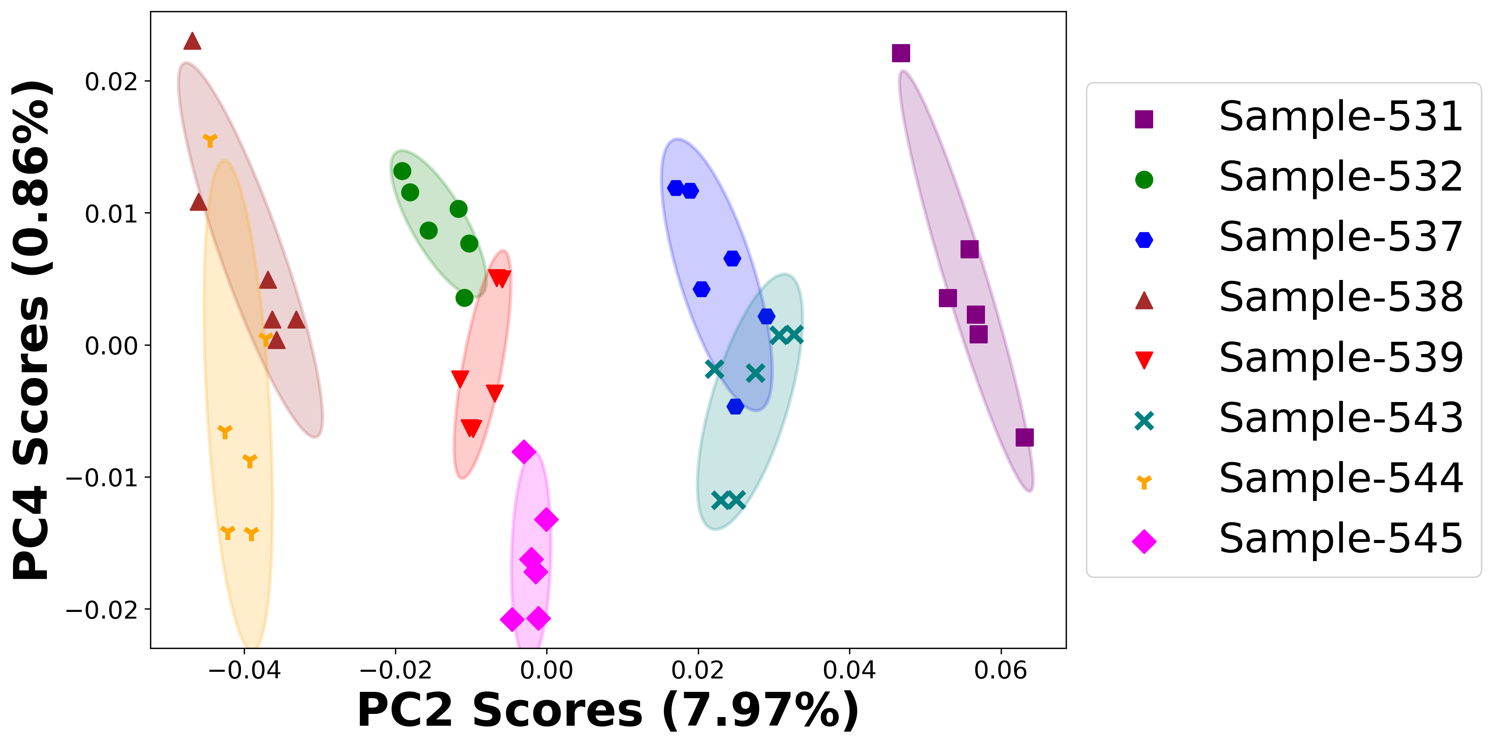

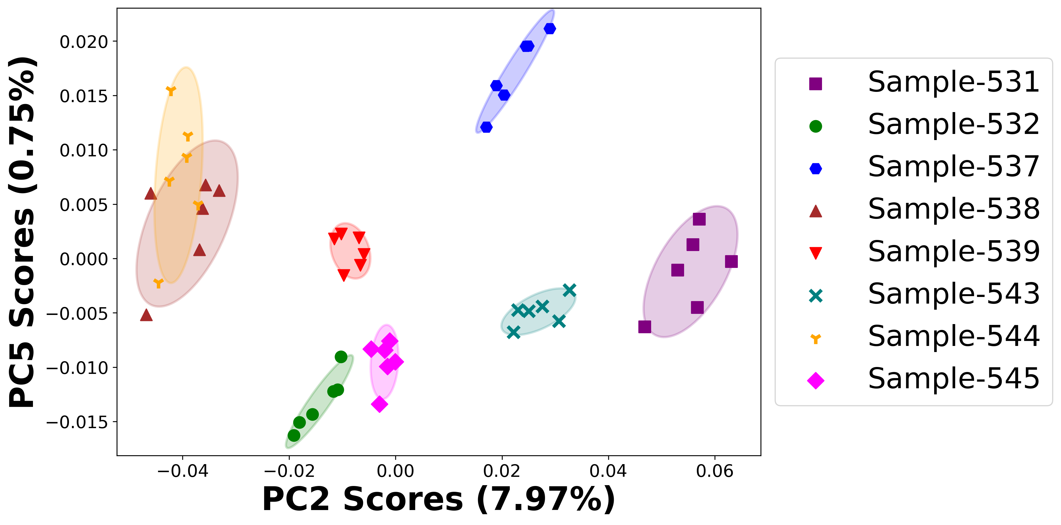

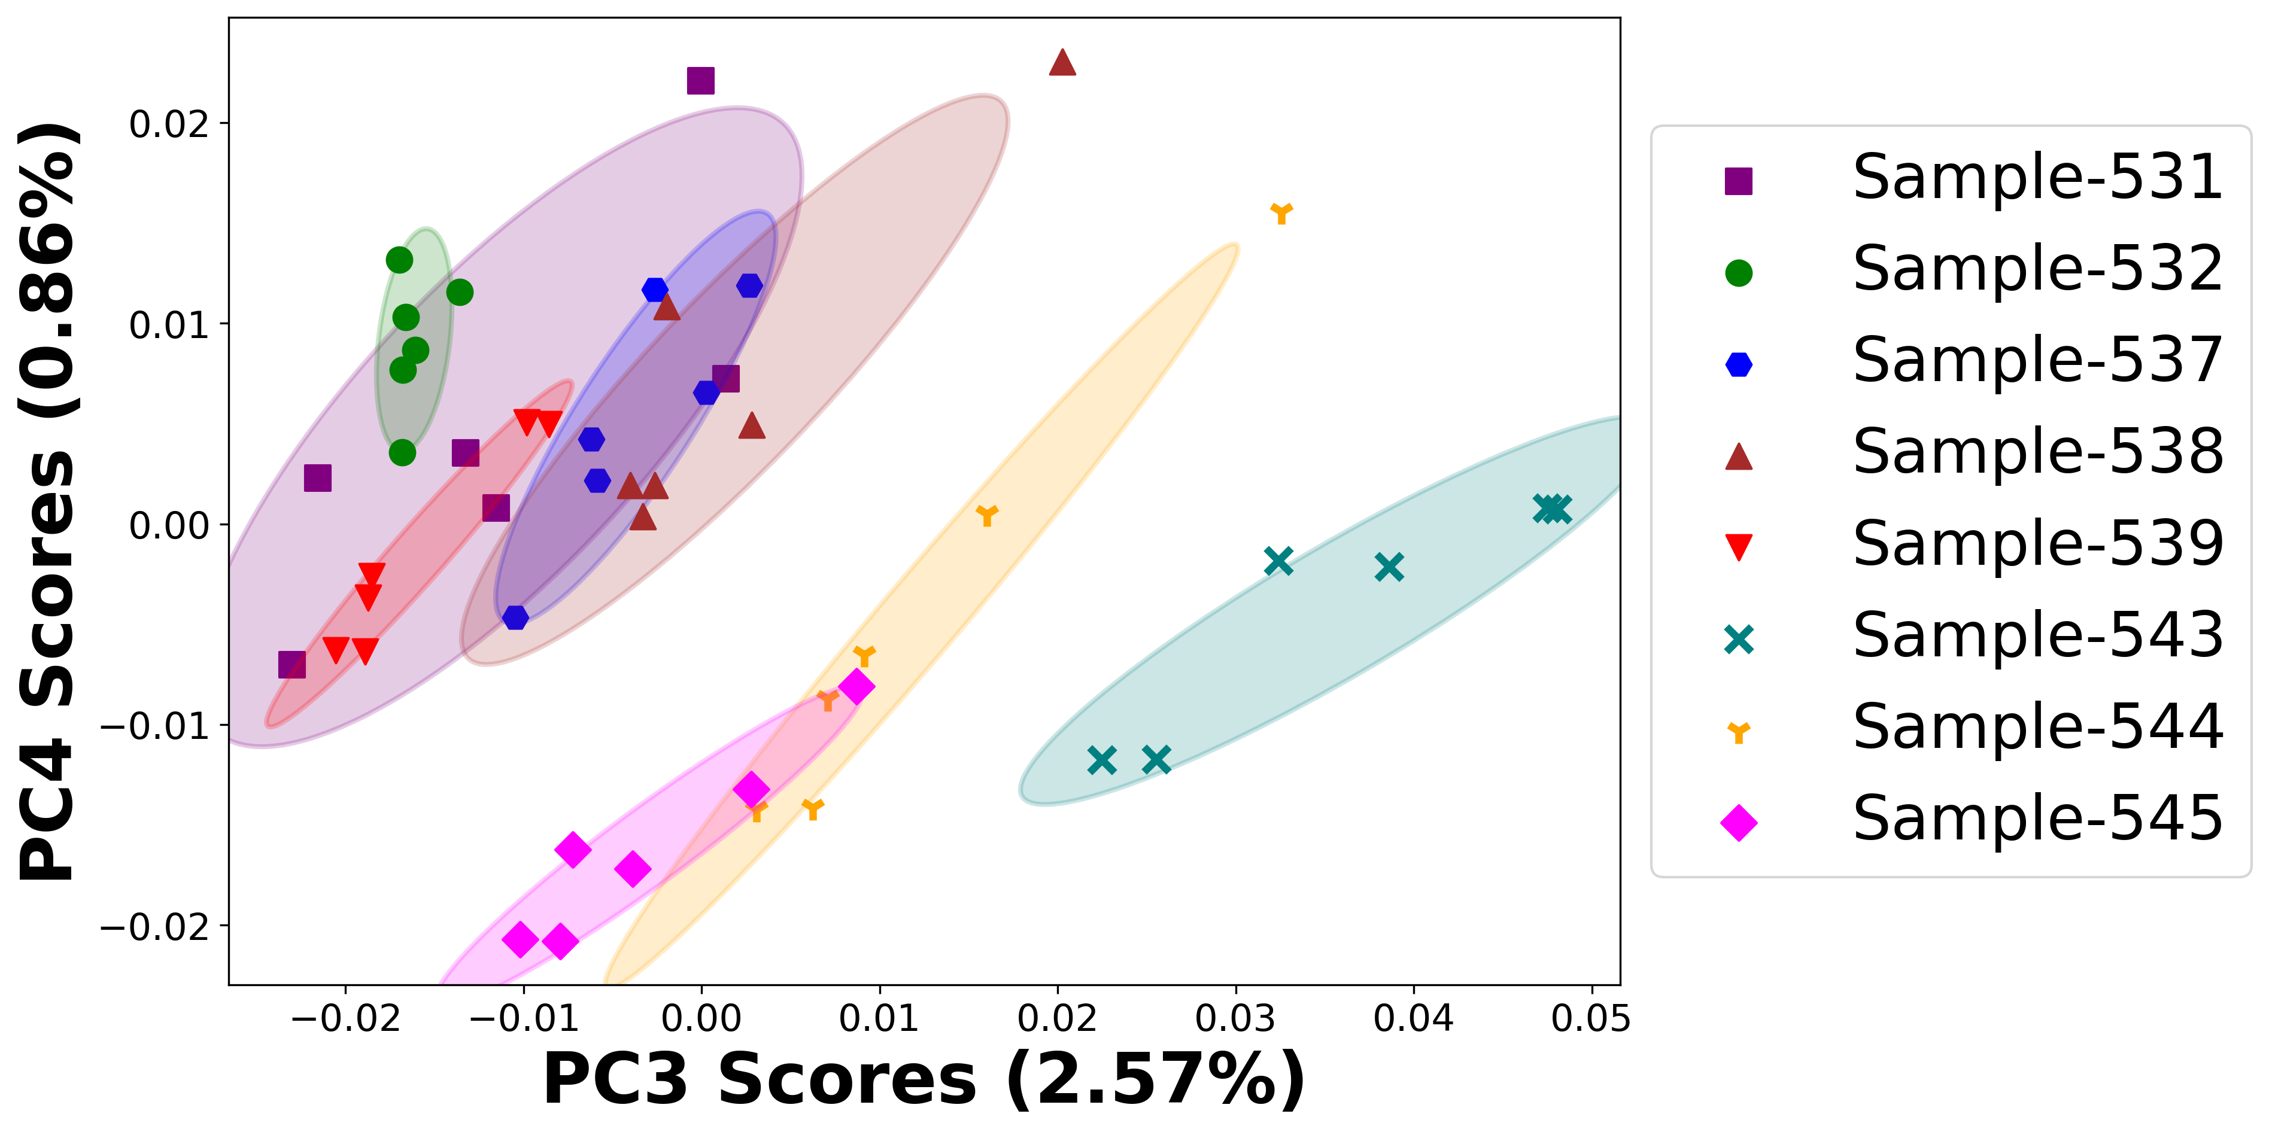

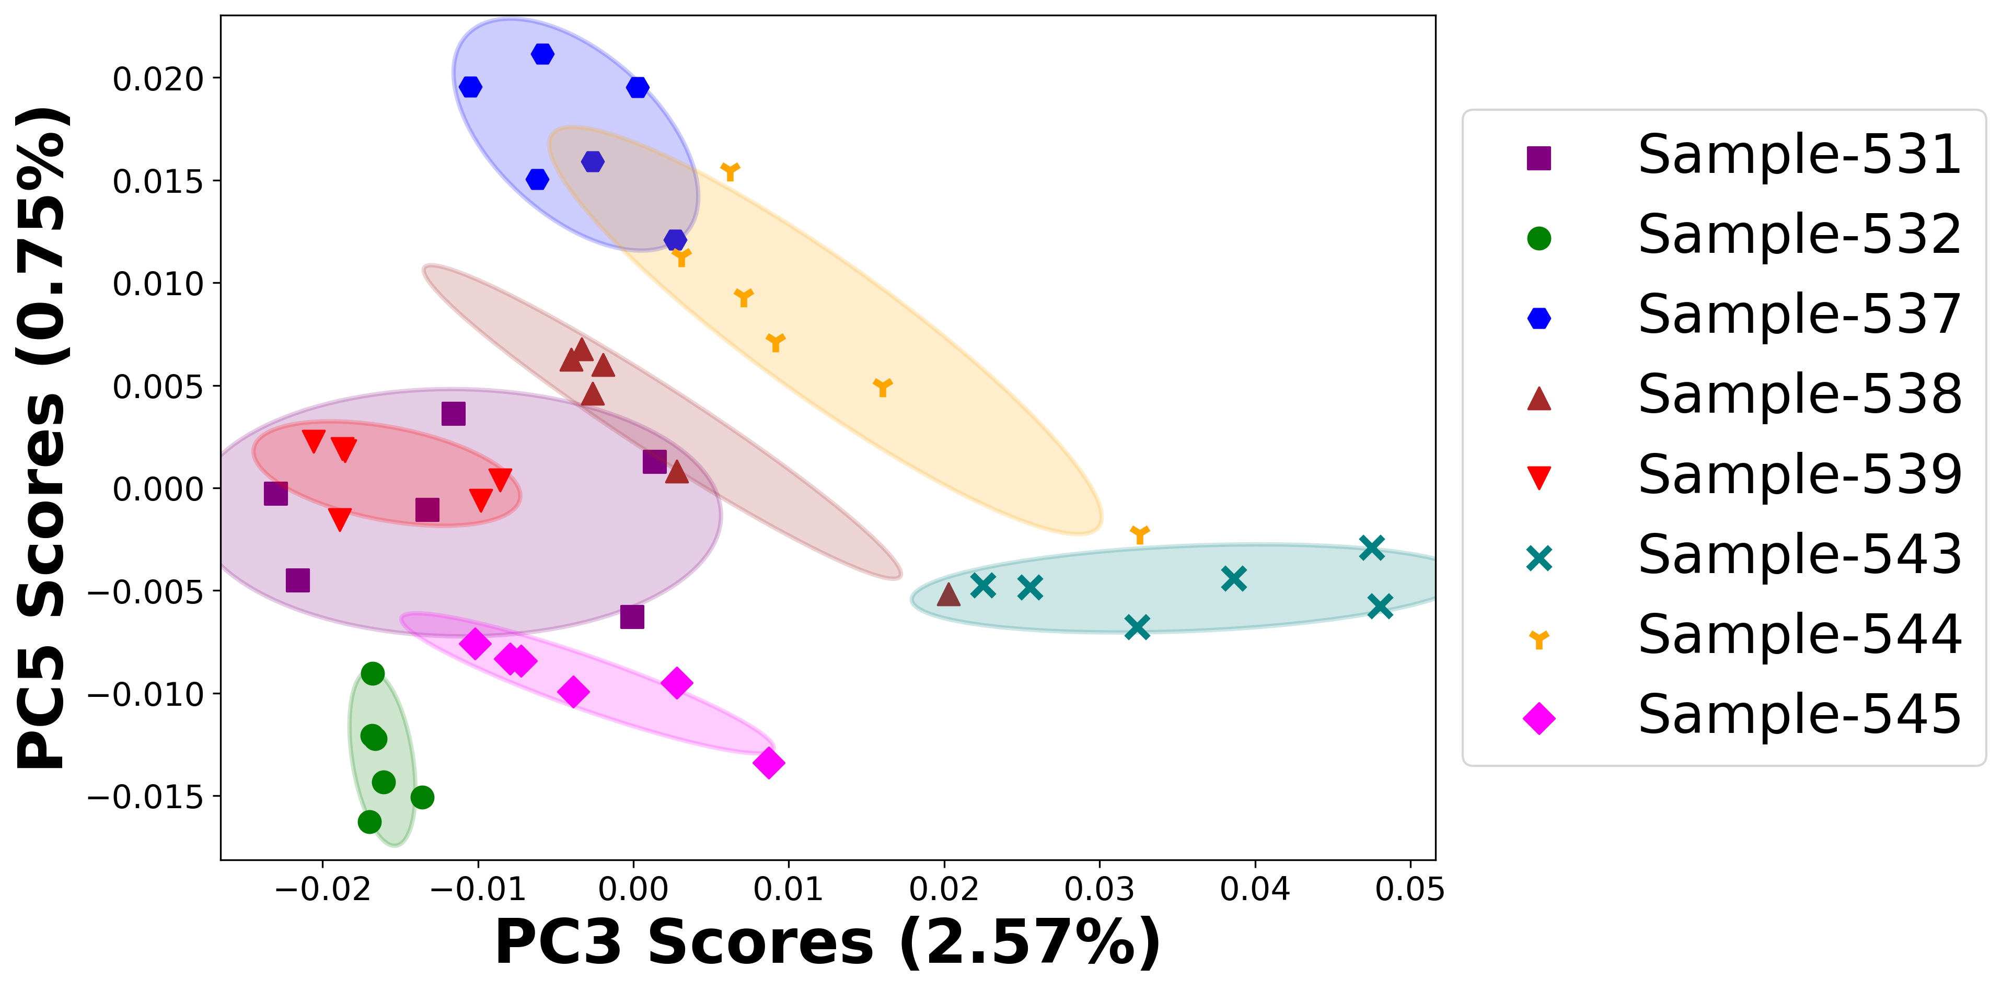

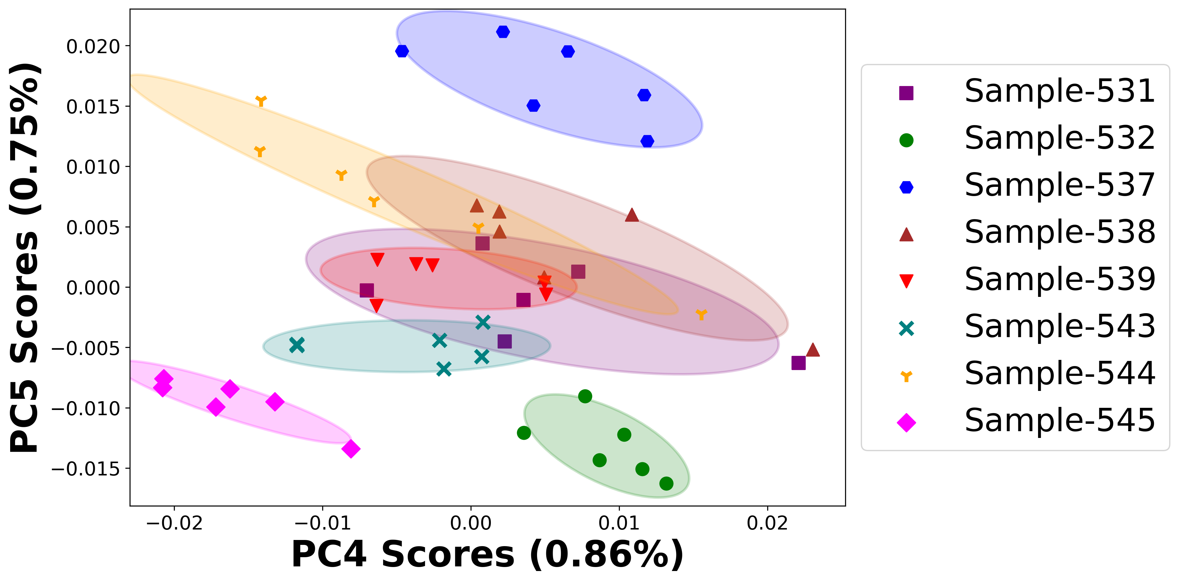

# Negative ion spectra, PCA analysis results -- PC1

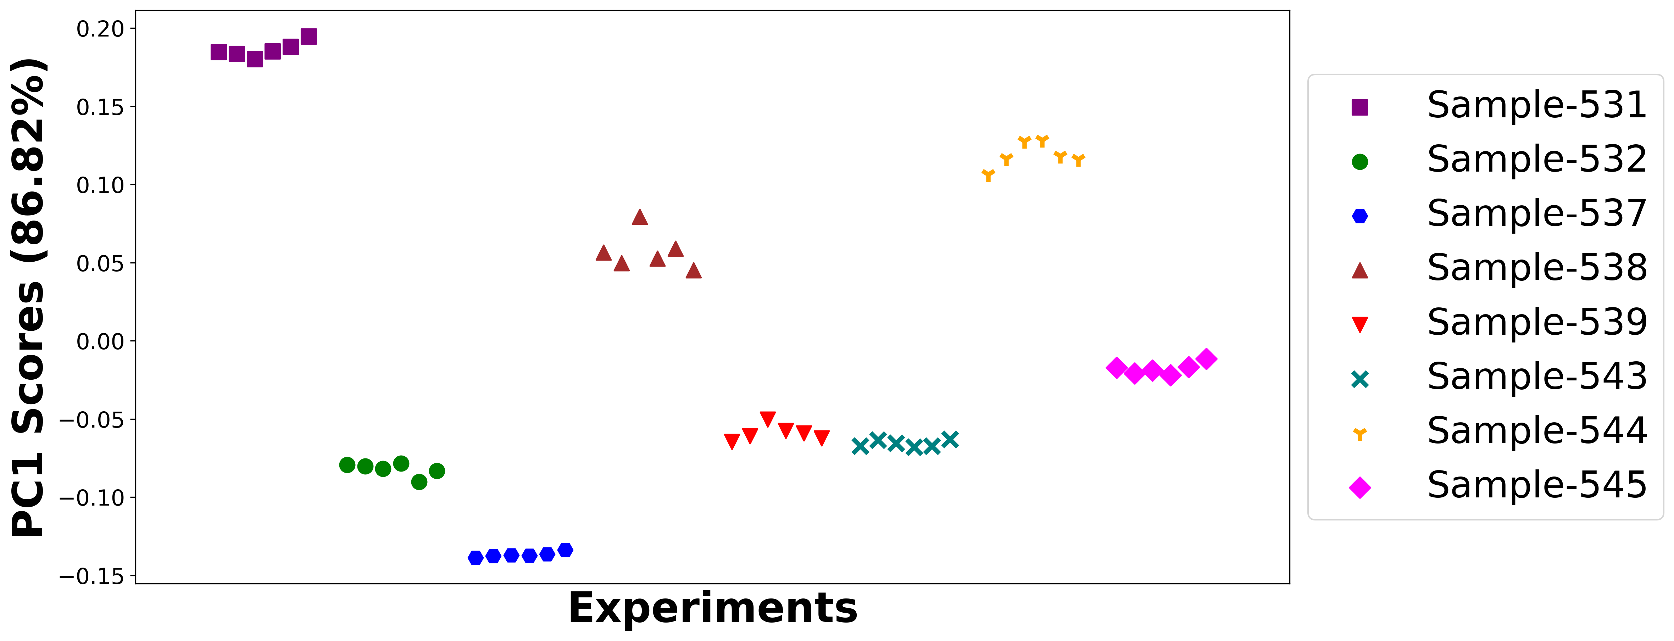

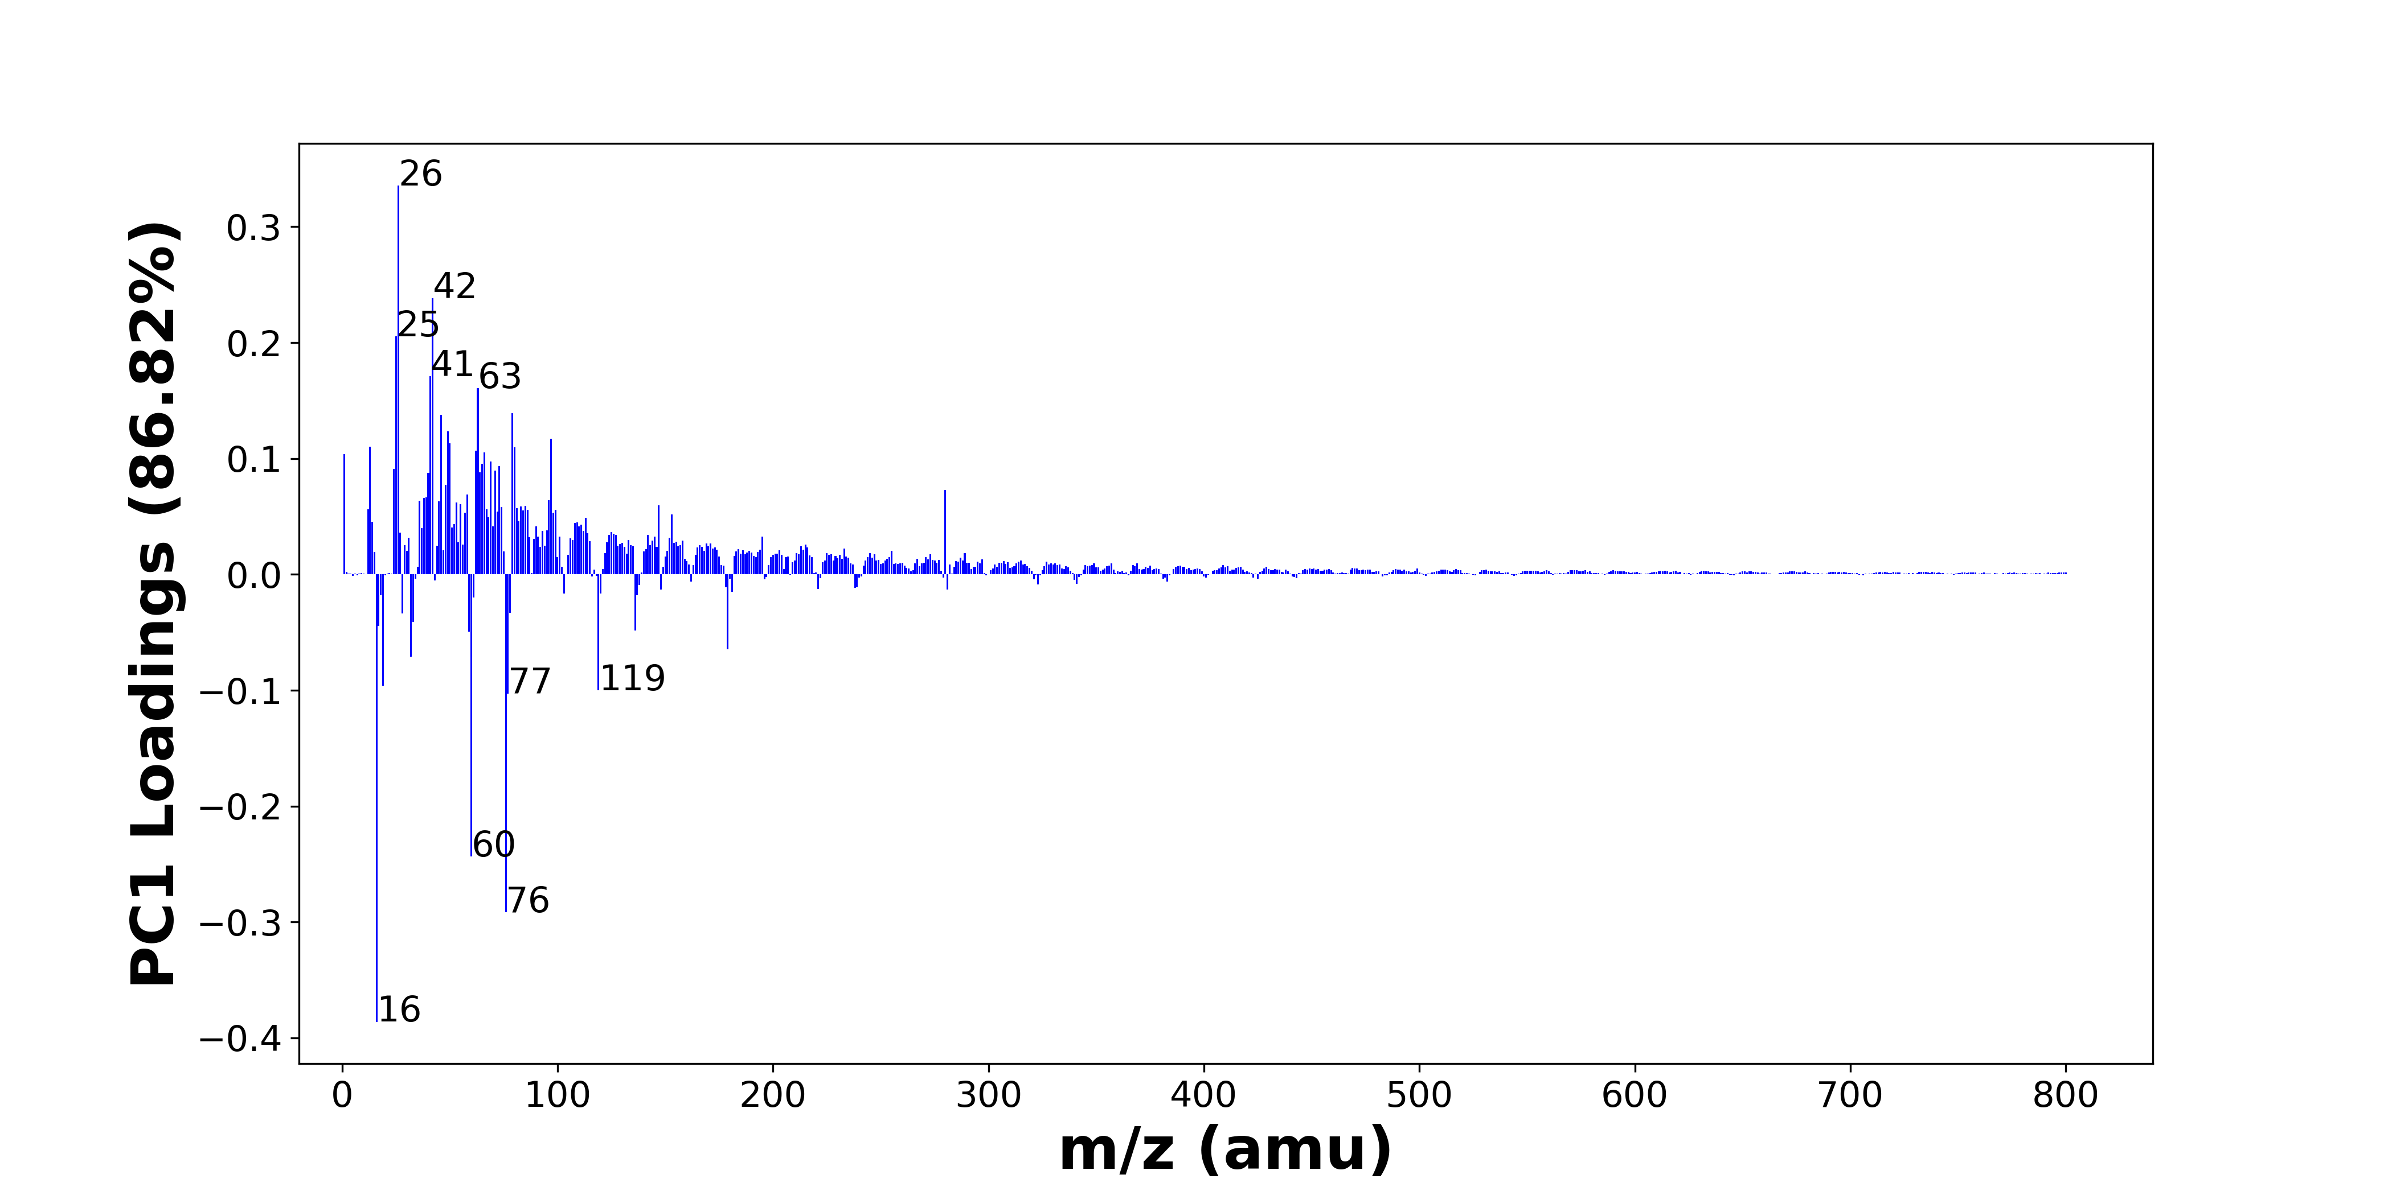

High score samples contain more:

* m/z 26 (CN-), m/z 42 (CNO-), m/z 25 (C2H-), m/z 41 (C2OH-), m/z 63 (PO2-), m/z 79 (PO3-), m/z 46 (NO2-), m/z 49 (C4H-), m/z 97 (H2PO4-, HSO4-), m/z 50 (C3N-), m/z 13 (CH-), m/z 80 (SO3-), m/z 62 (NO3-, 30SiO2-), m/z 66 (C3NO-), m/z 1 (H-), m/z 69 (C3HO2-), m/z 65 (C4OH-), m/z 73 (C6H-), m/z 24 (C2-), m/z 71 (C3H3O2-)
* Hydrocarbons, Nitrogen-containing organics, SOx, POx, NOx, Benzene-containing organics

Low score samples contain more:

* m/z 16 (O-), m/z 76 (SiO3-), m/z 60 (SiO2-), m/z 77 (SiO3H-), m/z 119 (NaSO4-), m/z 19 (F-), m/z 32 (O2-, S-), m/z 179 (Si4H3O4-, SiO2NaSO4-), m/z 59 (AlO2-, C2H3O2-), m/z 136 (Si2O5-), m/z 17 (OH-), m/z 33 (O2H-, SH-), m/z 28 (Si-), m/z 78 (SNO2-), m/z 61 (SiO2H-), m/z 18 (18O-), m/z 137 (Si2O5H-), m/z 103 (), m/z 120 (), m/z 181 (HSi3O6-)
* SiOx

# Negative ion spectra, top positive loadings -- PC1

|  |  |  |  |  |  |  |  |  |
| --- | --- | --- | --- | --- | --- | --- | --- | --- |
| + Loading No. | Unit Mass | Document Mass | Initial Peak Assignment | Initial Probabilities | Measured Mass | Peak Assignment (Qualified) | Updated Peak Assignment (from Document Mass) | Updated Document Mass |
| 1 | 26 | 26.0036 | CN- | 1.0 | 26.0039 | CN- |  |  |
| 2 | 42 | 41.9985 | CNO- | 1.0 | 42.0008 | CNO- |  |  |
| 3 | 25 | 25.0083 | C2H- | 1.0 | 25.0084 | C2H- |  |  |
| 4 | 41 | 41.0032 | C2OH- | 1.0 | 40.9964 | C2OH- |  |  |
| 5 | 63 | 62.9641 | PO2- | 1.0 | 62.9674 | PO2- |  |  |
| 6 | 79 | 78.959 | PO3- | 1.0 | 78.9654 | PO3- |  |  |
| 7 | 46 | 45.9934 | NO2- | 1.0 | 45.9935 | NO2- |  |  |
| 8 | 49 | 49.0083 | C4H- | 1.0 | 49.0093 | C4H- |  |  |
| 9 | 97 | 96.9696 96.9601 | H2PO4- HSO4- | 0.523 0.477 | 96.9638 | H2PO4- HSO4- |  |  |
| 10 | 50 | 50.0036 | C3N- | 1.0 | 50.0055 | C3N- |  |  |
| 11 | 13 | 13.0084 | CH- | 1.0 | 13.0084 | CH- |  |  |
| 12 | 80 | 79.9573 | SO3- | 1.0 | 79.9599 | SO3- |  |  |
| 13 | 62 | 61.9883 61.9641 | NO3- 30SiO2- | 0.562 0.438 | 61.9884 | NO3- 30SiO2- |  |  |
| 14 | 66 | 65.9985 | C3NO- | 1.0 |  |  |  |  |
| 15 | 1 | 1.0084 | H- | 1.0 | 1.0083 | H- |  |  |
| 16 | 69 | 68.9982 | C3HO2- | 1.0 |  |  |  |  |
| 17 | 65 | 65.0032 | C4OH- | 1.0 |  |  |  |  |
| 18 | 73 | 73.0083 | C6H- | 1.0 | 73.0080 | C6H- |  |  |
| 19 | 24 | 24.0005 | C2- | 1.0 |  |  |  |  |
| 20 | 71 | 71.0139 | C3H3O2- | 1.0 | 71.0160 | C3H3O2- |  |  |

Note: Highlighting of the qualified peak assignments represents the error in the document masses relative to the measured mass(es) in that row. Green signifies an error < 100ppm, yellow an error from 100 to 200ppm, and red an error > 200ppm.

# Negative ion spectra, top negative loadings -- PC1

|  |  |  |  |  |  |  |  |  |
| --- | --- | --- | --- | --- | --- | --- | --- | --- |
| - Loading No. | Unit Mass | Document Mass | Initial Peak Assignment | Initial Probabilities | Measured Mass | Peak Assignment (Qualified) | Updated Peak Assignment (from Document Mass) | Updated Document Mass |
| 1 | 16 | 15.9955 | O- | 1.0 | 15.9977 | O- |  |  |
| 2 | 76 | 75.9622 | SiO3- | 1.0 | 75.9672 | SiO3- |  |  |
| 3 | 60 | 59.9673 | SiO2- | 1.0 | 59.9712 | SiO2- |  |  |
| 4 | 77 | 76.9741 | SiO3H- | 1.0 | 76.9740 | SiO3H- |  |  |
| 5 | 119 | 118.942 | NaSO4- | 1.0 | 118.9416 | NaSO4- |  |  |
| 6 | 19 | 18.999 | F- | 1.0 | 18.9990 | F- |  |  |
| 7 | 32 | 31.9903 31.9726 | O2- S- | 0.542 0.458 | 31.9904 | O2- S- |  |  |
| 8 | 179 | 178.9114 178.9088 | Si4H3O4- SiO2NaSO4- | 0.507 0.493 | 178.9211 | Si4H3O4- SiO2NaSO4- |  |  |
| 9 | 59 | 58.9719 59.0139 | AlO2- C2H3O2- | 0.586 0.414 | 58.9739 59.0161 | AlO2- C2H3O2- |  |  |
| 10 | 136 | 135.9289 | Si2O5- | 1.0 | 135.9335 | Si2O5- |  |  |
| 11 | 17 | 17.0032 | OH- | 1.0 | 17.0044 | OH- |  |  |
| 12 | 33 | 32.9982 32.9804 | O2H- SH- | 0.53 0.47 |  |  |  |  |
| 13 | 28 | 27.9775 | Si- | 1.0 |  |  |  |  |
| 14 | 78 | 77.9655 | SNO2- | 1.0 |  |  |  |  |
| 15 | 61 | 60.9751 | SiO2H- | 1.0 | 60.9756 | SiO2H- |  |  |
| 16 | 18 | 17.9997 | 18O- | 1.0 |  |  |  |  |
| 17 | 137 | 136.9368 | Si2O5H- | 1.0 |  |  |  |  |
| 18 | 103 |  |  |  |  |  |  |  |
| 19 | 120 |  |  |  |  |  |  |  |
| 20 | 181 | 180.9087 | HSi3O6- | 1.0 |  |  |  |  |

Note: Highlighting of the qualified peak assignments represents the error in the document masses relative to the measured mass(es) in that row. Green signifies an error < 100ppm, yellow an error from 100 to 200ppm, and red an error > 200ppm.

# Negative ion spectra, molecular information from PC1 loadings plot

* The major positive PC1 loadings are m/z 26 (CN-), m/z 42 (CNO-), m/z 25 (C2H-), m/z 41 (C2OH-), m/z 63 (PO2-), m/z 79 (PO3-), m/z 46 (NO2-), m/z 49 (C4H-), m/z 97 (H2PO4-, HSO4-), m/z 50 (C3N-), m/z 13 (CH-), m/z 80 (SO3-), m/z 62 (NO3-, 30SiO2-), m/z 66 (C3NO-), m/z 1 (H-), m/z 69 (C3HO2-), m/z 65 (C4OH-), m/z 73 (C6H-), m/z 24 (C2-), m/z 71 (C3H3O2-), indicating they are more observed in high PC1 score samples.
* The major negative PC1 loadings are m/z 16 (O-), m/z 76 (SiO3-), m/z 60 (SiO2-), m/z 77 (SiO3H-), m/z 119 (NaSO4-), m/z 19 (F-), m/z 32 (O2-, S-), m/z 179 (Si4H3O4-, SiO2NaSO4-), m/z 59 (AlO2-, C2H3O2-), m/z 136 (Si2O5-), m/z 17 (OH-), m/z 33 (O2H-, SH-), m/z 28 (Si-), m/z 78 (SNO2-), m/z 61 (SiO2H-), m/z 18 (18O-), m/z 137 (Si2O5H-), m/z 103 (), m/z 120 (), m/z 181 (HSi3O6-), indicating they are more observed in low PC1 score samples.
* Hydrocarbons signals, such as m/z 13 (CH-), m/z 24 (C2-), m/z 25 (C2H-), are mostly found in positive loadings, indicating that high PC1 score samples contain more Hydrocarbons.
* Nitrogen-containing organics signals, such as m/z 26 (CN-), m/z 42 (CNO-), are mostly found in positive loadings, indicating that high PC1 score samples contain more Nitrogen-containing organics.
* SOx signals, such as m/z 80 (SO3-), are mostly found in positive loadings, indicating that high PC1 score samples contain more SOx.
* POx signals, such as m/z 63 (PO2-), m/z 79 (PO3-), are mostly found in positive loadings, indicating that high PC1 score samples contain more POx.
* NOx signals, such as m/z 46 (NO2-), m/z 62 (NO3-, 30SiO2-), are mostly found in positive loadings, indicating that high PC1 score samples contain more NOx.
* Benzene-containing organics signals, such as m/z 49 (C4H-), m/z 73 (C6H-), are mostly found in positive loadings, indicating that high PC1 score samples contain more Benzene-containing organics.
* SiOx signals, such as m/z 60 (SiO2-), m/z 61 (SiO2H-), m/z 76 (SiO3-), m/z 77 (SiO3H-), m/z 136 (Si2O5-), m/z 137 (Si2O5H-), are mostly found in negative loadings, indicating that low PC1 score samples contain more SiOx.

# Negative ion spectra, PCA analysis results -- PC2

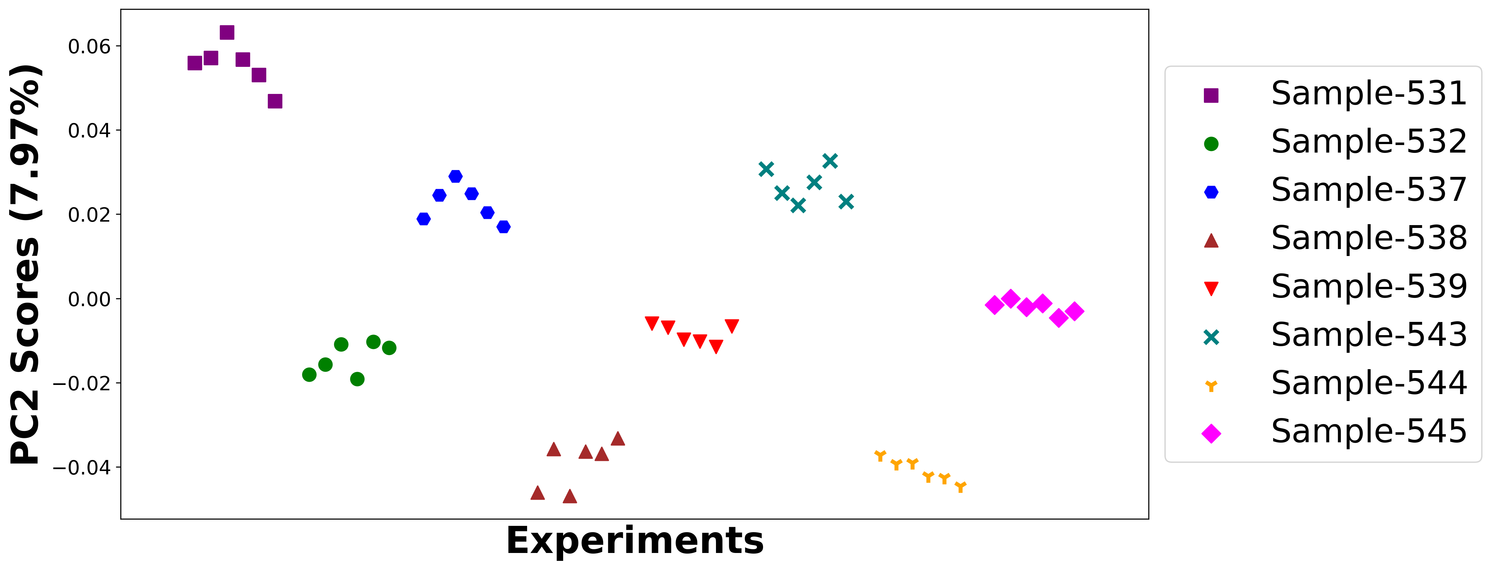

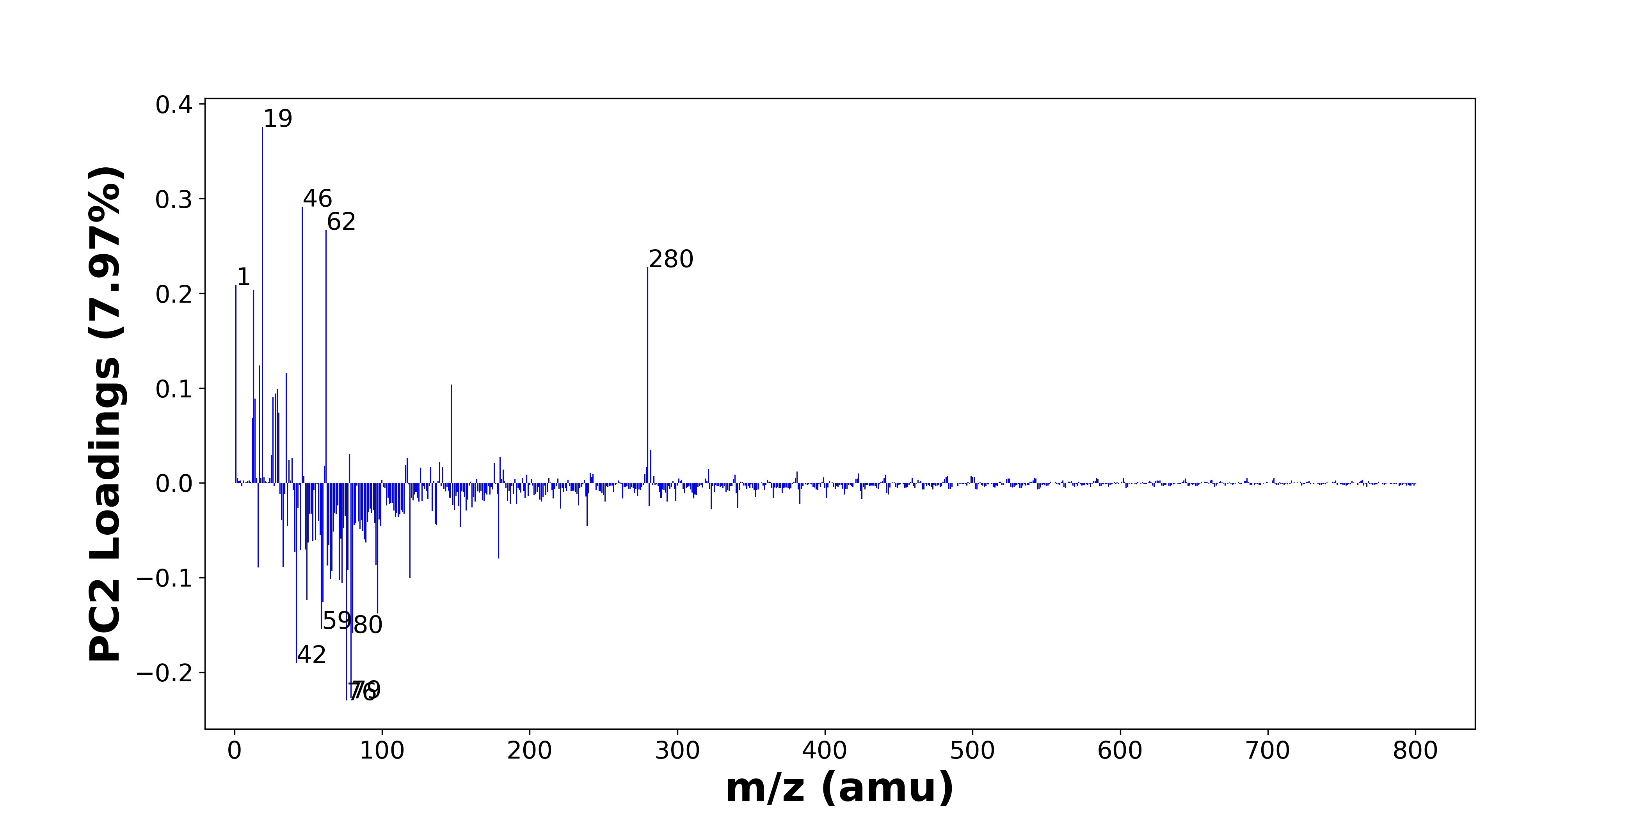

High score samples contain more:

* m/z 19 (F-), m/z 46 (NO2-), m/z 62 (NO3-, 30SiO2-), m/z 280 (), m/z 1 (H-), m/z 13 (CH-), m/z 17 (OH-), m/z 35 (Cl-), m/z 147 (Al4H7O2-), m/z 29 (SiH-, CHO-), m/z 28 (Si-), m/z 26 (CN-), m/z 14 (), m/z 30 (), m/z 12 (C-), m/z 282 (), m/z 78 (SNO2-), m/z 25 (C2H-), m/z 180 (Si3O6-), m/z 39 ()
* Hydrocarbons, NOx

Low score samples contain more:

* m/z 76 (SiO3-), m/z 79 (PO3-), m/z 42 (CNO-), m/z 80 (SO3-), m/z 59 (AlO2-, C2H3O2-), m/z 97 (H2PO4-, HSO4-), m/z 60 (SiO2-), m/z 49 (C4H-), m/z 73 (C6H-), m/z 71 (C3H3O2-), m/z 65 (C4OH-), m/z 119 (NaSO4-), m/z 66 (C3NO-), m/z 77 (SiO3H-), m/z 16 (O-), m/z 33 (O2H-, SH-), m/z 63 (PO2-), m/z 96 (SO4-), m/z 179 (Si4H3O4-, SiO2NaSO4-), m/z 41 (C2OH-)
* SiOx, SOx, POx, Benzene-containing organics

# Negative ion spectra, top positive loadings -- PC2

|  |  |  |  |  |  |  |  |  |
| --- | --- | --- | --- | --- | --- | --- | --- | --- |
| + Loading No. | Unit Mass | Document Mass | Initial Peak Assignment | Initial Probabilities | Measured Mass | Peak Assignment (Qualified) | Updated Peak Assignment (from Document Mass) | Updated Document Mass |
| 1 | 19 | 18.999 | F- | 1.0 | 18.9990 | F- |  |  |
| 2 | 46 | 45.9934 | NO2- | 1.0 | 45.9935 | NO2- |  |  |
| 3 | 62 | 61.9883 61.9641 | NO3- 30SiO2- | 0.562 0.438 | 61.9884 | NO3- 30SiO2- |  |  |
| 4 | 280 |  |  |  |  |  |  |  |
| 5 | 1 | 1.0084 | H- | 1.0 | 1.0083 | H- |  |  |
| 6 | 13 | 13.0084 | CH- | 1.0 | 13.0084 | CH- |  |  |
| 7 | 17 | 17.0032 | OH- | 1.0 | 17.0044 | OH- |  |  |
| 8 | 35 | 34.9694 | Cl- | 1.0 | 34.9698 | Cl- |  |  |
| 9 | 147 | 146.9713 | Al4H7O2- | 1.0 | 146.9683 | Al4H7O2- |  |  |
| 10 | 29 | 28.9853 29.0028 | SiH- CHO- | 0.54 0.46 | 28.9848 | SiH- CHO- |  |  |
| 11 | 28 | 27.9775 | Si- | 1.0 |  |  |  |  |
| 12 | 26 | 26.0036 | CN- | 1.0 | 26.0039 | CN- |  |  |
| 13 | 14 |  |  |  |  |  |  |  |
| 14 | 30 |  |  |  |  |  |  |  |
| 15 | 12 | 12.0005 | C- | 1.0 |  |  |  |  |
| 16 | 282 |  |  |  |  |  |  |  |
| 17 | 78 | 77.9655 | SNO2- | 1.0 |  |  |  |  |
| 18 | 25 | 25.0083 | C2H- | 1.0 | 25.0084 | C2H- |  |  |
| 19 | 180 | 179.9008 | Si3O6- | 1.0 |  |  |  |  |
| 20 | 39 |  |  |  |  |  |  |  |

Note: Highlighting of the qualified peak assignments represents the error in the document masses relative to the measured mass(es) in that row. Green signifies an error < 100ppm, yellow an error from 100 to 200ppm, and red an error > 200ppm.

# Negative ion spectra, top negative loadings -- PC2

|  |  |  |  |  |  |  |  |  |
| --- | --- | --- | --- | --- | --- | --- | --- | --- |
| - Loading No. | Unit Mass | Document Mass | Initial Peak Assignment | Initial Probabilities | Measured Mass | Peak Assignment (Qualified) | Updated Peak Assignment (from Document Mass) | Updated Document Mass |
| 1 | 76 | 75.9622 | SiO3- | 1.0 | 75.9672 | SiO3- |  |  |
| 2 | 79 | 78.959 | PO3- | 1.0 | 78.9654 | PO3- |  |  |
| 3 | 42 | 41.9985 | CNO- | 1.0 | 42.0008 | CNO- |  |  |
| 4 | 80 | 79.9573 | SO3- | 1.0 | 79.9599 | SO3- |  |  |
| 5 | 59 | 58.9719 59.0139 | AlO2- C2H3O2- | 0.586 0.414 | 58.9739 59.0161 | AlO2- C2H3O2- |  |  |
| 6 | 97 | 96.9696 96.9601 | H2PO4- HSO4- | 0.523 0.477 | 96.9638 | H2PO4- HSO4- |  |  |
| 7 | 60 | 59.9673 | SiO2- | 1.0 | 59.9712 | SiO2- |  |  |
| 8 | 49 | 49.0083 | C4H- | 1.0 | 49.0093 | C4H- |  |  |
| 9 | 73 | 73.0083 | C6H- | 1.0 | 73.0080 | C6H- |  |  |
| 10 | 71 | 71.0139 | C3H3O2- | 1.0 | 71.0160 | C3H3O2- |  |  |
| 11 | 65 | 65.0032 | C4OH- | 1.0 |  |  |  |  |
| 12 | 119 | 118.942 | NaSO4- | 1.0 | 118.9416 | NaSO4- |  |  |
| 13 | 66 | 65.9985 | C3NO- | 1.0 |  |  |  |  |
| 14 | 77 | 76.9741 | SiO3H- | 1.0 | 76.9740 | SiO3H- |  |  |
| 15 | 16 | 15.9955 | O- | 1.0 | 15.9977 | O- |  |  |
| 16 | 33 | 32.9982 32.9804 | O2H- SH- | 0.53 0.47 |  |  |  |  |
| 17 | 63 | 62.9641 | PO2- | 1.0 | 62.9674 | PO2- |  |  |
| 18 | 96 | 95.9522 | SO4- | 1.0 |  |  |  |  |
| 19 | 179 | 178.9114 178.9088 | Si4H3O4- SiO2NaSO4- | 0.507 0.493 | 178.9211 | Si4H3O4- SiO2NaSO4- |  |  |
| 20 | 41 | 41.0032 | C2OH- | 1.0 | 40.9964 | C2OH- |  |  |

Note: Highlighting of the qualified peak assignments represents the error in the document masses relative to the measured mass(es) in that row. Green signifies an error < 100ppm, yellow an error from 100 to 200ppm, and red an error > 200ppm.

# Negative ion spectra, molecular information from PC2 loadings plot

* The major positive PC2 loadings are m/z 19 (F-), m/z 46 (NO2-), m/z 62 (NO3-, 30SiO2-), m/z 280 (), m/z 1 (H-), m/z 13 (CH-), m/z 17 (OH-), m/z 35 (Cl-), m/z 147 (Al4H7O2-), m/z 29 (SiH-, CHO-), m/z 28 (Si-), m/z 26 (CN-), m/z 14 (), m/z 30 (), m/z 12 (C-), m/z 282 (), m/z 78 (SNO2-), m/z 25 (C2H-), m/z 180 (Si3O6-), m/z 39 (), indicating they are more observed in high PC2 score samples.
* The major negative PC2 loadings are m/z 76 (SiO3-), m/z 79 (PO3-), m/z 42 (CNO-), m/z 80 (SO3-), m/z 59 (AlO2-, C2H3O2-), m/z 97 (H2PO4-, HSO4-), m/z 60 (SiO2-), m/z 49 (C4H-), m/z 73 (C6H-), m/z 71 (C3H3O2-), m/z 65 (C4OH-), m/z 119 (NaSO4-), m/z 66 (C3NO-), m/z 77 (SiO3H-), m/z 16 (O-), m/z 33 (O2H-, SH-), m/z 63 (PO2-), m/z 96 (SO4-), m/z 179 (Si4H3O4-, SiO2NaSO4-), m/z 41 (C2OH-), indicating they are more observed in low PC2 score samples.
* Hydrocarbons signals, such as m/z 12 (C-), m/z 13 (CH-), m/z 25 (C2H-), are mostly found in positive loadings, indicating that high PC2 score samples contain more Hydrocarbons.
* NOx signals, such as m/z 46 (NO2-), m/z 62 (NO3-, 30SiO2-), are mostly found in positive loadings, indicating that high PC2 score samples contain more NOx.
* SiOx signals, such as m/z 60 (SiO2-), m/z 76 (SiO3-), m/z 77 (SiO3H-), are mostly found in negative loadings, indicating that low PC2 score samples contain more SiOx.
* SOx signals, such as m/z 80 (SO3-), m/z 96 (SO4-), are mostly found in negative loadings, indicating that low PC2 score samples contain more SOx.
* POx signals, such as m/z 63 (PO2-), m/z 79 (PO3-), are mostly found in negative loadings, indicating that low PC2 score samples contain more POx.
* Benzene-containing organics signals, such as m/z 49 (C4H-), m/z 73 (C6H-), are mostly found in negative loadings, indicating that low PC2 score samples contain more Benzene-containing organics.

# Negative ion spectra, PCA analysis results -- PC3

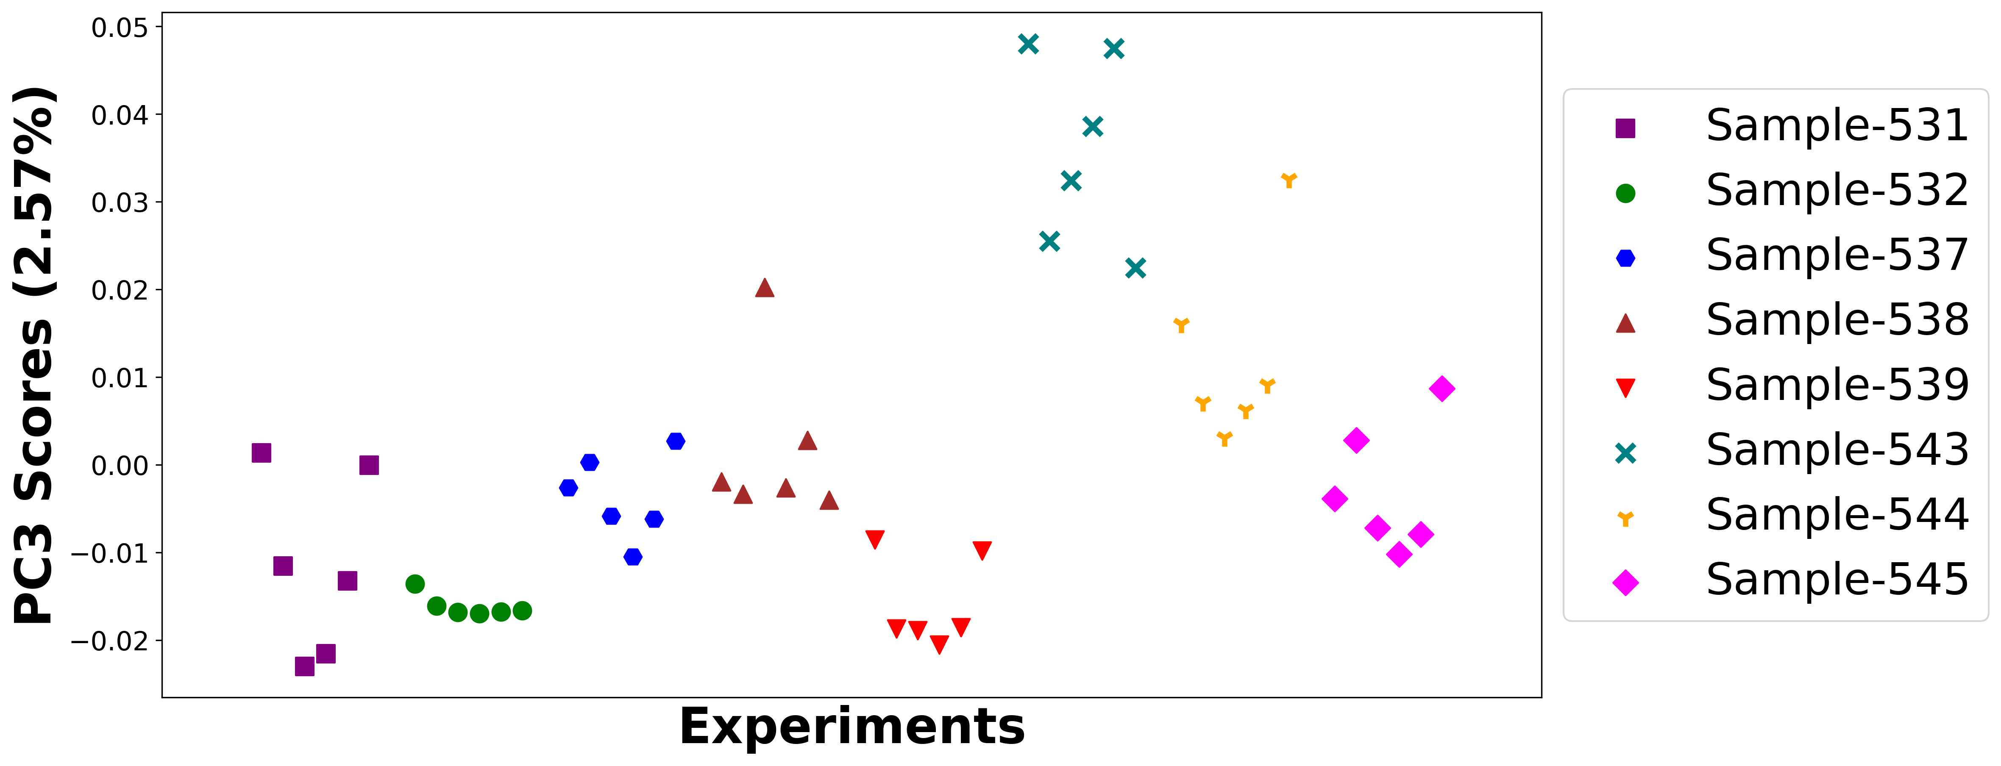

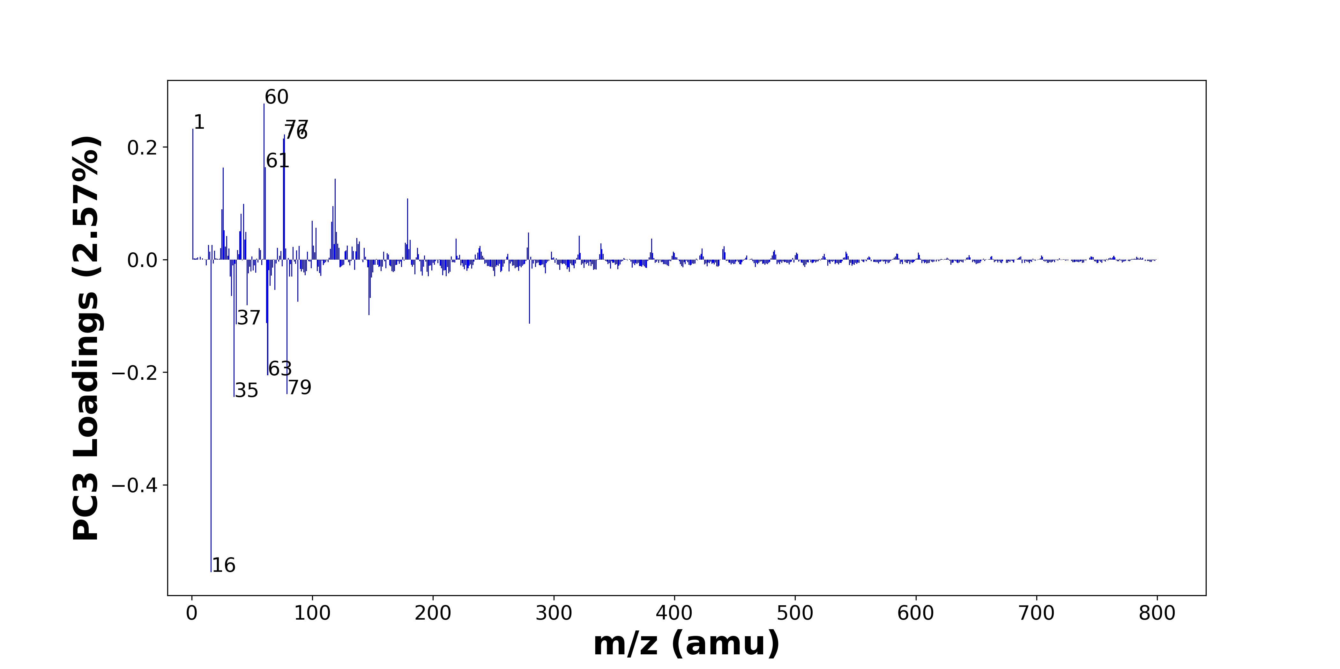

High score samples contain more:

* m/z 60 (SiO2-), m/z 1 (H-), m/z 77 (SiO3H-), m/z 76 (SiO3-), m/z 61 (SiO2H-), m/z 26 (CN-), m/z 119 (NaSO4-), m/z 179 (Si4H3O4-, SiO2NaSO4-), m/z 43 (CHNO-, BO2-, C2H3O-, AlO-), m/z 117 (Si4H5-), m/z 25 (C2H-), m/z 41 (C2OH-), m/z 100 (), m/z 116 (), m/z 103 (), m/z 27 (), m/z 40 (C2O-), m/z 45 (CO2H-), m/z 120 (), m/z 279 ()
* SiOx, Organic acids

Low score samples contain more:

* m/z 16 (O-), m/z 35 (Cl-), m/z 79 (PO3-), m/z 63 (PO2-), m/z 37 (37Cl-, C3H-), m/z 280 (), m/z 62 (NO3-, 30SiO2-), m/z 147 (Al4H7O2-), m/z 46 (NO2-), m/z 88 (FeO2-), m/z 148 (), m/z 33 (O2H-, SH-), m/z 69 (C3HO2-), m/z 65 (C4OH-), m/z 149 (), m/z 81 (), m/z 32 (O2-, S-), m/z 83 (), m/z 211 (), m/z 196 ()
* POx, NOx

# Negative ion spectra, top positive loadings -- PC3

|  |  |  |  |  |  |  |  |  |
| --- | --- | --- | --- | --- | --- | --- | --- | --- |
| + Loading No. | Unit Mass | Document Mass | Initial Peak Assignment | Initial Probabilities | Measured Mass | Peak Assignment (Qualified) | Updated Peak Assignment (from Document Mass) | Updated Document Mass |
| 1 | 60 | 59.9673 | SiO2- | 1.0 | 59.9712 | SiO2- |  |  |
| 2 | 1 | 1.0084 | H- | 1.0 | 1.0083 | H- |  |  |
| 3 | 77 | 76.9741 | SiO3H- | 1.0 | 76.9740 | SiO3H- |  |  |
| 4 | 76 | 75.9622 | SiO3- | 1.0 | 75.9672 | SiO3- |  |  |
| 5 | 61 | 60.9751 | SiO2H- | 1.0 | 60.9756 | SiO2H- |  |  |
| 6 | 26 | 26.0036 | CN- | 1.0 | 26.0039 | CN- |  |  |
| 7 | 119 | 118.942 | NaSO4- | 1.0 | 118.9416 | NaSO4- |  |  |
| 8 | 179 | 178.9114 178.9088 | Si4H3O4- SiO2NaSO4- | 0.507 0.493 | 178.9211 | Si4H3O4- SiO2NaSO4- |  |  |
| 9 | 43 | 43.0064 42.9996 43.0189 42.977 | CHNO- BO2- C2H3O- AlO- | 0.281 0.263 0.25 0.206 | 42.9810 43.0033 43.0229 | CHNO- BO2- C2H3O- AlO- |  |  |
| 10 | 117 | 116.9474 | Si4H5- | 1.0 | 116.9478 | Si4H5- |  |  |
| 11 | 25 | 25.0083 | C2H- | 1.0 | 25.0084 | C2H- |  |  |
| 12 | 41 | 41.0032 | C2OH- | 1.0 | 40.9964 | C2OH- |  |  |
| 13 | 100 |  |  |  |  |  |  |  |
| 14 | 116 |  |  |  |  |  |  |  |
| 15 | 103 |  |  |  |  |  |  |  |
| 16 | 27 |  |  |  |  |  |  |  |
| 17 | 40 | 39.9954 | C2O- | 1.0 |  |  |  |  |
| 18 | 45 | 44.9982 | CO2H- | 1.0 |  |  |  |  |
| 19 | 120 |  |  |  |  |  |  |  |
| 20 | 279 |  |  |  |  |  |  |  |

Note: Highlighting of the qualified peak assignments represents the error in the document masses relative to the measured mass(es) in that row. Green signifies an error < 100ppm, yellow an error from 100 to 200ppm, and red an error > 200ppm.

# Negative ion spectra, top negative loadings -- PC3

|  |  |  |  |  |  |  |  |  |
| --- | --- | --- | --- | --- | --- | --- | --- | --- |
| - Loading No. | Unit Mass | Document Mass | Initial Peak Assignment | Initial Probabilities | Measured Mass | Peak Assignment (Qualified) | Updated Peak Assignment (from Document Mass) | Updated Document Mass |
| 1 | 16 | 15.9955 | O- | 1.0 | 15.9977 | O- |  |  |
| 2 | 35 | 34.9694 | Cl- | 1.0 | 34.9698 | Cl- |  |  |
| 3 | 79 | 78.959 | PO3- | 1.0 | 78.9654 | PO3- |  |  |
| 4 | 63 | 62.9641 | PO2- | 1.0 | 62.9674 | PO2- |  |  |
| 5 | 37 | 36.9664 37.0084 | 37Cl- C3H- | 0.589 0.411 | 37.0083 36.9666 | 37Cl- C3H- |  |  |
| 6 | 280 |  |  |  |  |  |  |  |
| 7 | 62 | 61.9883 61.9641 | NO3- 30SiO2- | 0.562 0.438 | 61.9884 | NO3- 30SiO2- |  |  |
| 8 | 147 | 146.9713 | Al4H7O2- | 1.0 | 146.9683 | Al4H7O2- |  |  |
| 9 | 46 | 45.9934 | NO2- | 1.0 | 45.9935 | NO2- |  |  |
| 10 | 88 | 87.9253 | FeO2- | 1.0 | 87.9284 | FeO2- |  |  |
| 11 | 148 |  |  |  |  |  |  |  |
| 12 | 33 | 32.9982 32.9804 | O2H- SH- | 0.53 0.47 |  |  |  |  |
| 13 | 69 | 68.9982 | C3HO2- | 1.0 |  |  |  |  |
| 14 | 65 | 65.0032 | C4OH- | 1.0 |  |  |  |  |
| 15 | 149 |  |  |  |  |  |  |  |
| 16 | 81 |  |  |  |  |  |  |  |
| 17 | 32 | 31.9903 31.9726 | O2- S- | 0.542 0.458 | 31.9904 | O2- S- |  |  |
| 18 | 83 |  |  |  |  |  |  |  |
| 19 | 211 |  |  |  |  |  |  |  |
| 20 | 196 |  |  |  |  |  |  |  |

Note: Highlighting of the qualified peak assignments represents the error in the document masses relative to the measured mass(es) in that row. Green signifies an error < 100ppm, yellow an error from 100 to 200ppm, and red an error > 200ppm.

# Negative ion spectra, molecular information from PC3 loadings plot

* The major positive PC3 loadings are m/z 60 (SiO2-), m/z 1 (H-), m/z 77 (SiO3H-), m/z 76 (SiO3-), m/z 61 (SiO2H-), m/z 26 (CN-), m/z 119 (NaSO4-), m/z 179 (Si4H3O4-, SiO2NaSO4-), m/z 43 (CHNO-, BO2-, C2H3O-, AlO-), m/z 117 (Si4H5-), m/z 25 (C2H-), m/z 41 (C2OH-), m/z 100 (), m/z 116 (), m/z 103 (), m/z 27 (), m/z 40 (C2O-), m/z 45 (CO2H-), m/z 120 (), m/z 279 (), indicating they are more observed in high PC3 score samples.
* The major negative PC3 loadings are m/z 16 (O-), m/z 35 (Cl-), m/z 79 (PO3-), m/z 63 (PO2-), m/z 37 (37Cl-, C3H-), m/z 280 (), m/z 62 (NO3-, 30SiO2-), m/z 147 (Al4H7O2-), m/z 46 (NO2-), m/z 88 (FeO2-), m/z 148 (), m/z 33 (O2H-, SH-), m/z 69 (C3HO2-), m/z 65 (C4OH-), m/z 149 (), m/z 81 (), m/z 32 (O2-, S-), m/z 83 (), m/z 211 (), m/z 196 (), indicating they are more observed in low PC3 score samples.
* SiOx signals, such as m/z 60 (SiO2-), m/z 61 (SiO2H-), m/z 76 (SiO3-), m/z 77 (SiO3H-), are mostly found in positive loadings, indicating that high PC3 score samples contain more SiOx.
* Organic acids signals, such as m/z 45 (CO2H-), are mostly found in positive loadings, indicating that high PC3 score samples contain more Organic acids.
* POx signals, such as m/z 63 (PO2-), m/z 79 (PO3-), are mostly found in negative loadings, indicating that low PC3 score samples contain more POx.
* NOx signals, such as m/z 46 (NO2-), m/z 62 (NO3-, 30SiO2-), are mostly found in negative loadings, indicating that low PC3 score samples contain more NOx.

# Negative ion spectra, PCA analysis results -- PC4

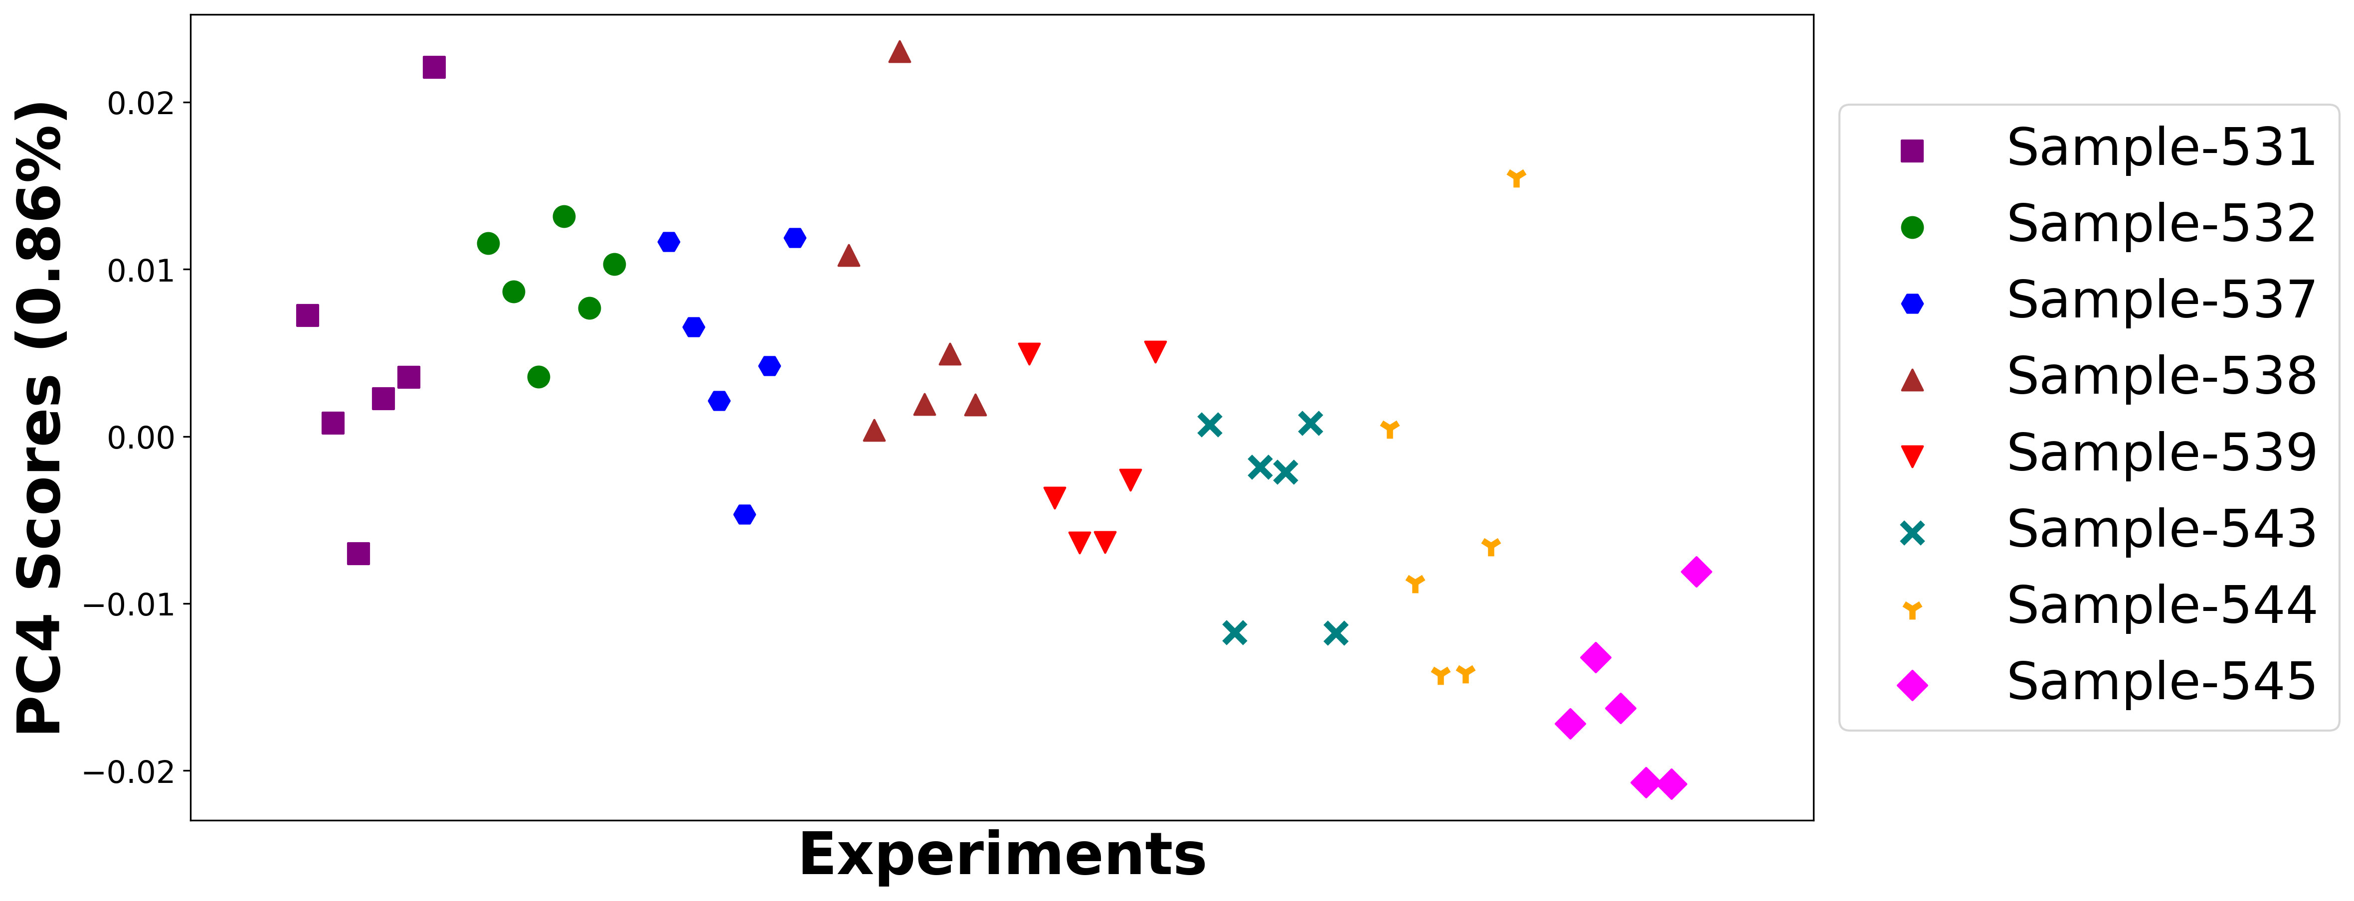

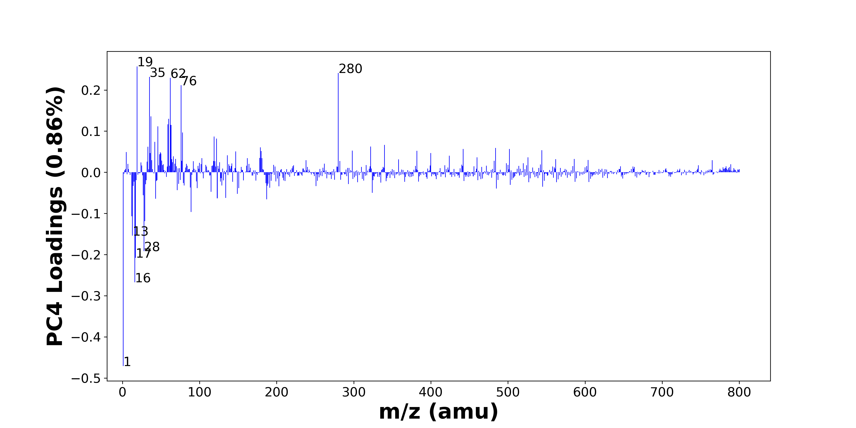

High score samples contain more:

* m/z 19 (F-), m/z 280 (), m/z 35 (Cl-), m/z 62 (NO3-, 30SiO2-), m/z 76 (SiO3-), m/z 37 (37Cl-, C3H-), m/z 60 (SiO2-), m/z 59 (AlO2-, C2H3O2-), m/z 63 (PO2-), m/z 46 (NO2-), m/z 78 (SNO2-), m/z 119 (NaSO4-), m/z 122 (), m/z 42 (CNO-), m/z 340 (), m/z 322 (), m/z 33 (O2H-, SH-), m/z 179 (Si4H3O4-, SiO2NaSO4-), m/z 484 (), m/z 442 ()
* SiOx, NOx

Low score samples contain more:

* m/z 1 (H-), m/z 16 (O-), m/z 17 (OH-), m/z 28 (Si-), m/z 13 (CH-), m/z 29 (SiH-, CHO-), m/z 12 (C-), m/z 89 (), m/z 187 (), m/z 43 (CHNO-, BO2-, C2H3O-, AlO-), m/z 123 (), m/z 134 (), m/z 27 (), m/z 149 (), m/z 324 (), m/z 115 (), m/z 71 (C3H3O2-), m/z 485 (), m/z 151 (), m/z 97 (H2PO4-, HSO4-)
* Hydrocarbons

# Negative ion spectra, top positive loadings -- PC4

|  |  |  |  |  |  |  |  |  |
| --- | --- | --- | --- | --- | --- | --- | --- | --- |
| + Loading No. | Unit Mass | Document Mass | Initial Peak Assignment | Initial Probabilities | Measured Mass | Peak Assignment (Qualified) | Updated Peak Assignment (from Document Mass) | Updated Document Mass |
| 1 | 19 | 18.999 | F- | 1.0 | 18.9990 | F- |  |  |
| 2 | 280 |  |  |  |  |  |  |  |
| 3 | 35 | 34.9694 | Cl- | 1.0 | 34.9698 | Cl- |  |  |
| 4 | 62 | 61.9883 61.9641 | NO3- 30SiO2- | 0.562 0.438 | 61.9884 | NO3- 30SiO2- |  |  |
| 5 | 76 | 75.9622 | SiO3- | 1.0 | 75.9672 | SiO3- |  |  |
| 6 | 37 | 36.9664 37.0084 | 37Cl- C3H- | 0.589 0.411 | 37.0083 36.9666 | 37Cl- C3H- |  |  |
| 7 | 60 | 59.9673 | SiO2- | 1.0 | 59.9712 | SiO2- |  |  |
| 8 | 59 | 58.9719 59.0139 | AlO2- C2H3O2- | 0.586 0.414 | 58.9739 59.0161 | AlO2- C2H3O2- |  |  |
| 9 | 63 | 62.9641 | PO2- | 1.0 | 62.9674 | PO2- |  |  |
| 10 | 46 | 45.9934 | NO2- | 1.0 | 45.9935 | NO2- |  |  |
| 11 | 78 | 77.9655 | SNO2- | 1.0 |  |  |  |  |
| 12 | 119 | 118.942 | NaSO4- | 1.0 | 118.9416 | NaSO4- |  |  |
| 13 | 122 |  |  |  |  |  |  |  |
| 14 | 42 | 41.9985 | CNO- | 1.0 | 42.0008 | CNO- |  |  |
| 15 | 340 |  |  |  |  |  |  |  |
| 16 | 322 |  |  |  |  |  |  |  |
| 17 | 33 | 32.9982 32.9804 | O2H- SH- | 0.53 0.47 |  |  |  |  |
| 18 | 179 | 178.9114 178.9088 | Si4H3O4- SiO2NaSO4- | 0.507 0.493 | 178.9211 | Si4H3O4- SiO2NaSO4- |  |  |
| 19 | 484 |  |  |  |  |  |  |  |
| 20 | 442 |  |  |  |  |  |  |  |

Note: Highlighting of the qualified peak assignments represents the error in the document masses relative to the measured mass(es) in that row. Green signifies an error < 100ppm, yellow an error from 100 to 200ppm, and red an error > 200ppm.

# Negative ion spectra, top negative loadings -- PC4

|  |  |  |  |  |  |  |  |  |
| --- | --- | --- | --- | --- | --- | --- | --- | --- |
| - Loading No. | Unit Mass | Document Mass | Initial Peak Assignment | Initial Probabilities | Measured Mass | Peak Assignment (Qualified) | Updated Peak Assignment (from Document Mass) | Updated Document Mass |
| 1 | 1 | 1.0084 | H- | 1.0 | 1.0083 | H- |  |  |
| 2 | 16 | 15.9955 | O- | 1.0 | 15.9977 | O- |  |  |
| 3 | 17 | 17.0032 | OH- | 1.0 | 17.0044 | OH- |  |  |
| 4 | 28 | 27.9775 | Si- | 1.0 |  |  |  |  |
| 5 | 13 | 13.0084 | CH- | 1.0 | 13.0084 | CH- |  |  |
| 6 | 29 | 28.9853 29.0028 | SiH- CHO- | 0.54 0.46 | 28.9848 | SiH- CHO- |  |  |
| 7 | 12 | 12.0005 | C- | 1.0 |  |  |  |  |
| 8 | 89 |  |  |  |  |  |  |  |
| 9 | 187 |  |  |  |  |  |  |  |
| 10 | 43 | 43.0064 42.9996 43.0189 42.977 | CHNO- BO2- C2H3O- AlO- | 0.281 0.263 0.25 0.206 | 42.9810 43.0033 43.0229 | CHNO- BO2- C2H3O- AlO- |  |  |
| 11 | 123 |  |  |  |  |  |  |  |
| 12 | 134 |  |  |  |  |  |  |  |
| 13 | 27 |  |  |  |  |  |  |  |
| 14 | 149 |  |  |  |  |  |  |  |
| 15 | 324 |  |  |  |  |  |  |  |
| 16 | 115 |  |  |  |  |  |  |  |
| 17 | 71 | 71.0139 | C3H3O2- | 1.0 | 71.0160 | C3H3O2- |  |  |
| 18 | 485 |  |  |  |  |  |  |  |
| 19 | 151 |  |  |  |  |  |  |  |
| 20 | 97 | 96.9696 96.9601 | H2PO4- HSO4- | 0.523 0.477 | 96.9638 | H2PO4- HSO4- |  |  |

Note: Highlighting of the qualified peak assignments represents the error in the document masses relative to the measured mass(es) in that row. Green signifies an error < 100ppm, yellow an error from 100 to 200ppm, and red an error > 200ppm.

# Negative ion spectra, molecular information from PC4 loadings plot

* The major positive PC4 loadings are m/z 19 (F-), m/z 280 (), m/z 35 (Cl-), m/z 62 (NO3-, 30SiO2-), m/z 76 (SiO3-), m/z 37 (37Cl-, C3H-), m/z 60 (SiO2-), m/z 59 (AlO2-, C2H3O2-), m/z 63 (PO2-), m/z 46 (NO2-), m/z 78 (SNO2-), m/z 119 (NaSO4-), m/z 122 (), m/z 42 (CNO-), m/z 340 (), m/z 322 (), m/z 33 (O2H-, SH-), m/z 179 (Si4H3O4-, SiO2NaSO4-), m/z 484 (), m/z 442 (), indicating they are more observed in high PC4 score samples.
* The major negative PC4 loadings are m/z 1 (H-), m/z 16 (O-), m/z 17 (OH-), m/z 28 (Si-), m/z 13 (CH-), m/z 29 (SiH-, CHO-), m/z 12 (C-), m/z 89 (), m/z 187 (), m/z 43 (CHNO-, BO2-, C2H3O-, AlO-), m/z 123 (), m/z 134 (), m/z 27 (), m/z 149 (), m/z 324 (), m/z 115 (), m/z 71 (C3H3O2-), m/z 485 (), m/z 151 (), m/z 97 (H2PO4-, HSO4-), indicating they are more observed in low PC4 score samples.
* SiOx signals, such as m/z 60 (SiO2-), m/z 76 (SiO3-), are mostly found in positive loadings, indicating that high PC4 score samples contain more SiOx.
* NOx signals, such as m/z 46 (NO2-), m/z 62 (NO3-, 30SiO2-), are mostly found in positive loadings, indicating that high PC4 score samples contain more NOx.
* Hydrocarbons signals, such as m/z 12 (C-), m/z 13 (CH-), are mostly found in negative loadings, indicating that low PC4 score samples contain more Hydrocarbons.

# Negative ion spectra, PCA analysis results -- PC5

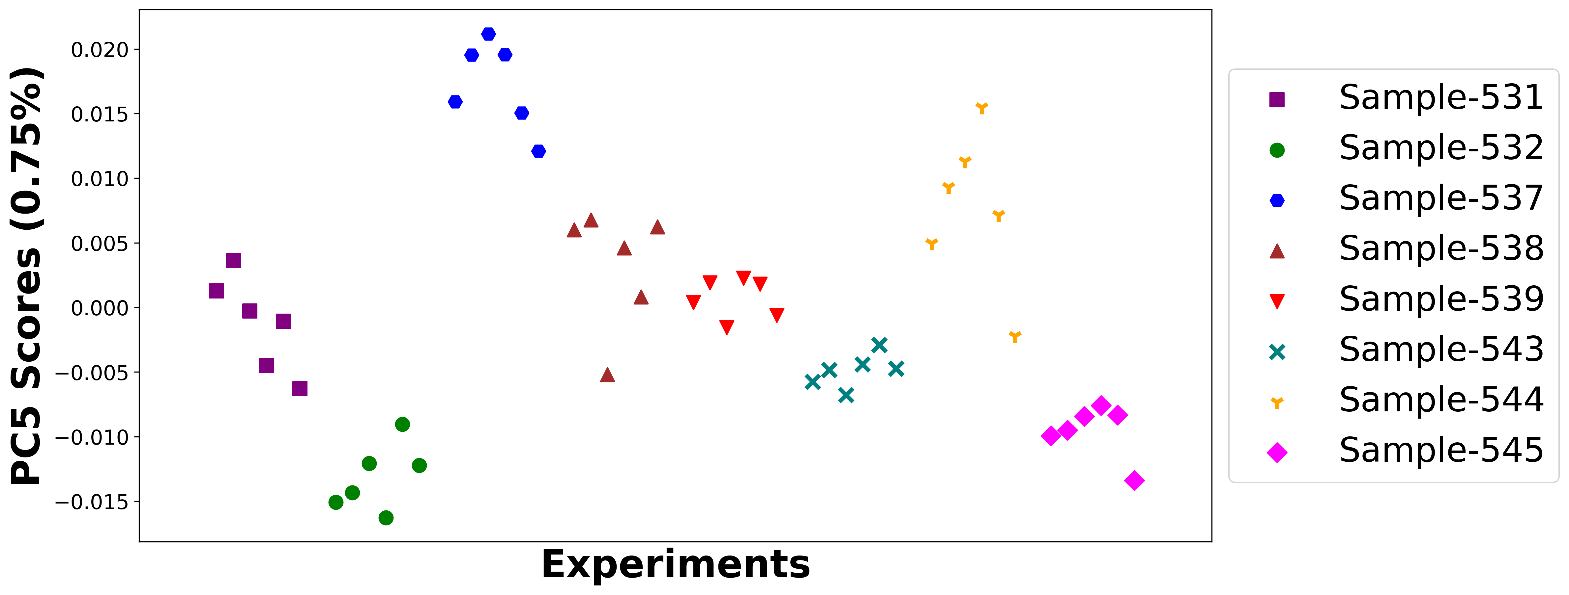

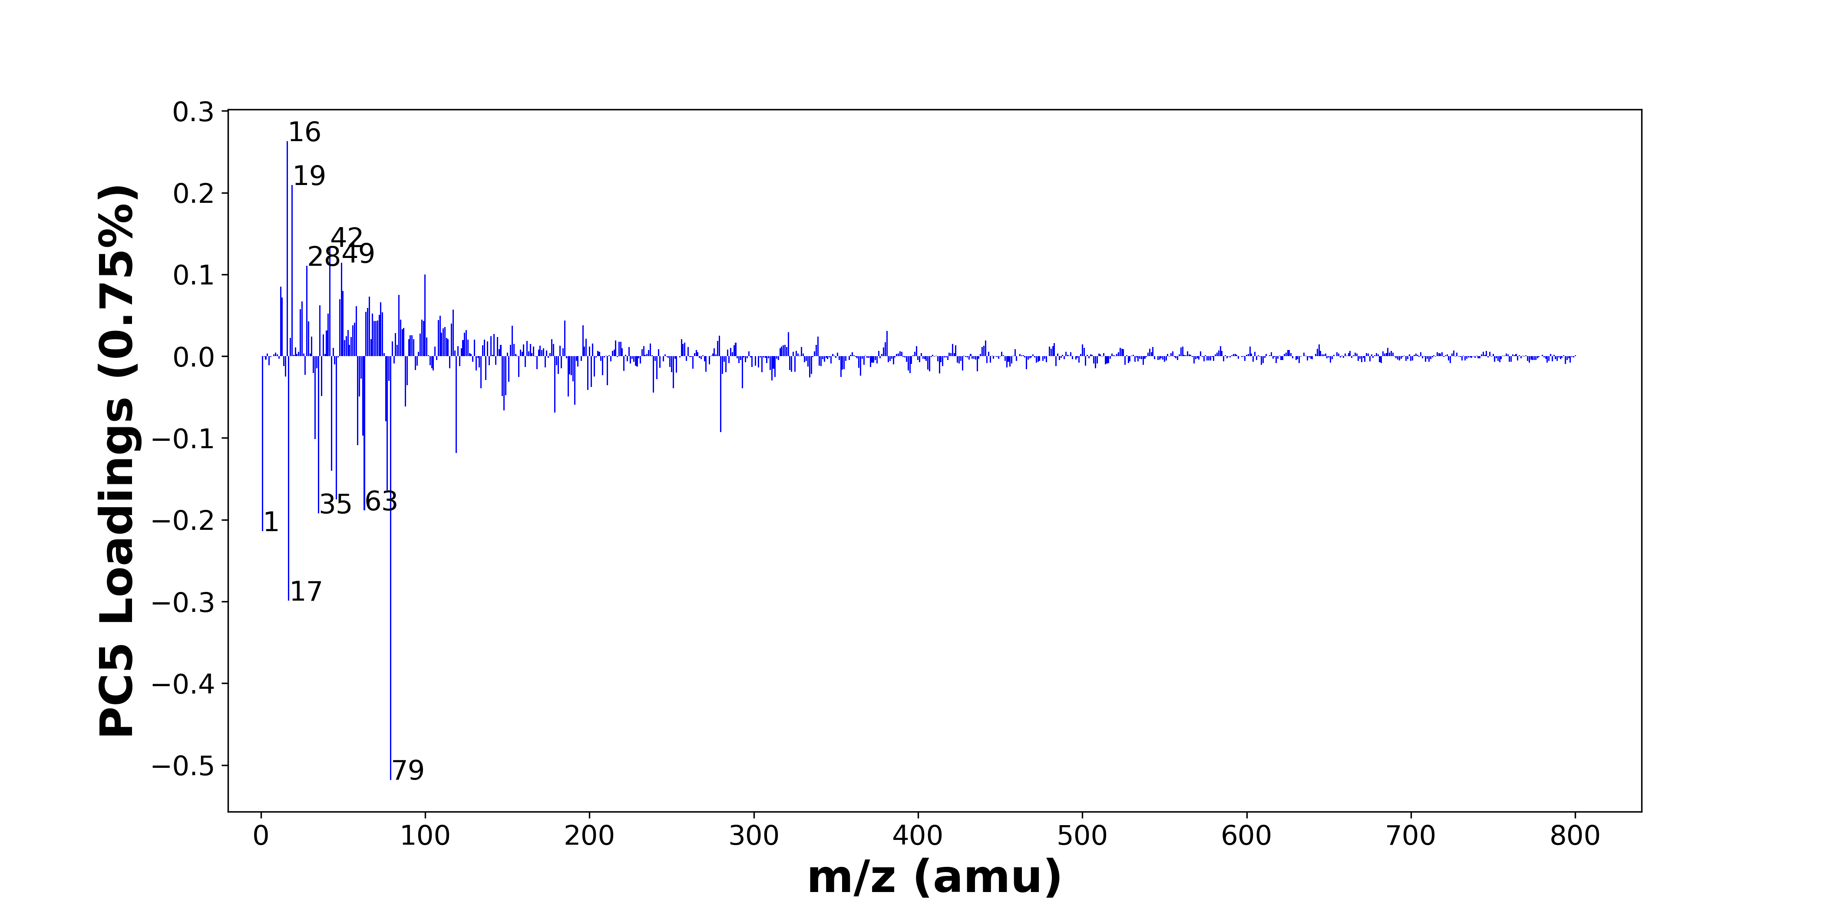

High score samples contain more:

* m/z 16 (O-), m/z 19 (F-), m/z 42 (CNO-), m/z 49 (C4H-), m/z 28 (Si-), m/z 100 (), m/z 12 (C-), m/z 50 (C3N-), m/z 84 (), m/z 66 (C3NO-), m/z 13 (CH-), m/z 48 (C4-), m/z 25 (C2H-), m/z 73 (C6H-), m/z 36 (C3-), m/z 58 (C2H2O2-), m/z 65 (C4OH-), m/z 24 (C2-), m/z 117 (Si4H5-), m/z 64 (SO2-)
* Hydrocarbons, Nitrogen-containing organics, SOx, Benzene-containing organics

Low score samples contain more:

* m/z 79 (PO3-), m/z 17 (OH-), m/z 1 (H-), m/z 35 (Cl-), m/z 63 (PO2-), m/z 46 (NO2-), m/z 77 (SiO3H-), m/z 43 (CHNO-, BO2-, C2H3O-, AlO-), m/z 119 (NaSO4-), m/z 59 (AlO2-, C2H3O2-), m/z 33 (O2H-, SH-), m/z 62 (NO3-, 30SiO2-), m/z 280 (), m/z 76 (SiO3-), m/z 179 (Si4H3O4-, SiO2NaSO4-), m/z 148 (), m/z 88 (FeO2-), m/z 191 (), m/z 187 (), m/z 60 (SiO2-)
* SiOx, POx, NOx

# Negative ion spectra, top positive loadings -- PC5

|  |  |  |  |  |  |  |  |  |
| --- | --- | --- | --- | --- | --- | --- | --- | --- |
| + Loading No. | Unit Mass | Document Mass | Initial Peak Assignment | Initial Probabilities | Measured Mass | Peak Assignment (Qualified) | Updated Peak Assignment (from Document Mass) | Updated Document Mass |
| 1 | 16 | 15.9955 | O- | 1.0 | 15.9977 | O- |  |  |
| 2 | 19 | 18.999 | F- | 1.0 | 18.9990 | F- |  |  |
| 3 | 42 | 41.9985 | CNO- | 1.0 | 42.0008 | CNO- |  |  |
| 4 | 49 | 49.0083 | C4H- | 1.0 | 49.0093 | C4H- |  |  |
| 5 | 28 | 27.9775 | Si- | 1.0 |  |  |  |  |
| 6 | 100 |  |  |  |  |  |  |  |
| 7 | 12 | 12.0005 | C- | 1.0 |  |  |  |  |
| 8 | 50 | 50.0036 | C3N- | 1.0 | 50.0055 | C3N- |  |  |
| 9 | 84 |  |  |  |  |  |  |  |
| 10 | 66 | 65.9985 | C3NO- | 1.0 |  |  |  |  |
| 11 | 13 | 13.0084 | CH- | 1.0 | 13.0084 | CH- |  |  |
| 12 | 48 | 48.0005 | C4- | 1.0 |  |  |  |  |
| 13 | 25 | 25.0083 | C2H- | 1.0 | 25.0084 | C2H- |  |  |
| 14 | 73 | 73.0083 | C6H- | 1.0 | 73.0080 | C6H- |  |  |
| 15 | 36 | 36.0005 | C3- | 1.0 |  |  |  |  |
| 16 | 58 | 58.006 | C2H2O2- | 1.0 |  |  |  |  |
| 17 | 65 | 65.0032 | C4OH- | 1.0 |  |  |  |  |
| 18 | 24 | 24.0005 | C2- | 1.0 |  |  |  |  |
| 19 | 117 | 116.9474 | Si4H5- | 1.0 | 116.9478 | Si4H5- |  |  |
| 20 | 64 | 63.9624 | SO2- | 1.0 |  |  |  |  |

Note: Highlighting of the qualified peak assignments represents the error in the document masses relative to the measured mass(es) in that row. Green signifies an error < 100ppm, yellow an error from 100 to 200ppm, and red an error > 200ppm.

# Negative ion spectra, top negative loadings -- PC5

|  |  |  |  |  |  |  |  |  |
| --- | --- | --- | --- | --- | --- | --- | --- | --- |
| - Loading No. | Unit Mass | Document Mass | Initial Peak Assignment | Initial Probabilities | Measured Mass | Peak Assignment (Qualified) | Updated Peak Assignment (from Document Mass) | Updated Document Mass |
| 1 | 79 | 78.959 | PO3- | 1.0 | 78.9654 | PO3- |  |  |
| 2 | 17 | 17.0032 | OH- | 1.0 | 17.0044 | OH- |  |  |
| 3 | 1 | 1.0084 | H- | 1.0 | 1.0083 | H- |  |  |
| 4 | 35 | 34.9694 | Cl- | 1.0 | 34.9698 | Cl- |  |  |
| 5 | 63 | 62.9641 | PO2- | 1.0 | 62.9674 | PO2- |  |  |
| 6 | 46 | 45.9934 | NO2- | 1.0 | 45.9935 | NO2- |  |  |
| 7 | 77 | 76.9741 | SiO3H- | 1.0 | 76.9740 | SiO3H- |  |  |
| 8 | 43 | 43.0064 42.9996 43.0189 42.977 | CHNO- BO2- C2H3O- AlO- | 0.281 0.263 0.25 0.206 | 42.9810 43.0033 43.0229 | CHNO- BO2- C2H3O- AlO- |  |  |
| 9 | 119 | 118.942 | NaSO4- | 1.0 | 118.9416 | NaSO4- |  |  |
| 10 | 59 | 58.9719 59.0139 | AlO2- C2H3O2- | 0.586 0.414 | 58.9739 59.0161 | AlO2- C2H3O2- |  |  |
| 11 | 33 | 32.9982 32.9804 | O2H- SH- | 0.53 0.47 |  |  |  |  |
| 12 | 62 | 61.9883 61.9641 | NO3- 30SiO2- | 0.562 0.438 | 61.9884 | NO3- 30SiO2- |  |  |
| 13 | 280 |  |  |  |  |  |  |  |
| 14 | 76 | 75.9622 | SiO3- | 1.0 | 75.9672 | SiO3- |  |  |
| 15 | 179 | 178.9114 178.9088 | Si4H3O4- SiO2NaSO4- | 0.507 0.493 | 178.9211 | Si4H3O4- SiO2NaSO4- |  |  |
| 16 | 148 |  |  |  |  |  |  |  |
| 17 | 88 | 87.9253 | FeO2- | 1.0 | 87.9284 | FeO2- |  |  |
| 18 | 191 |  |  |  |  |  |  |  |
| 19 | 187 |  |  |  |  |  |  |  |
| 20 | 60 | 59.9673 | SiO2- | 1.0 | 59.9712 | SiO2- |  |  |

Note: Highlighting of the qualified peak assignments represents the error in the document masses relative to the measured mass(es) in that row. Green signifies an error < 100ppm, yellow an error from 100 to 200ppm, and red an error > 200ppm.

# Negative ion spectra, molecular information from PC5 loadings plot

* The major positive PC5 loadings are m/z 16 (O-), m/z 19 (F-), m/z 42 (CNO-), m/z 49 (C4H-), m/z 28 (Si-), m/z 100 (), m/z 12 (C-), m/z 50 (C3N-), m/z 84 (), m/z 66 (C3NO-), m/z 13 (CH-), m/z 48 (C4-), m/z 25 (C2H-), m/z 73 (C6H-), m/z 36 (C3-), m/z 58 (C2H2O2-), m/z 65 (C4OH-), m/z 24 (C2-), m/z 117 (Si4H5-), m/z 64 (SO2-), indicating they are more observed in high PC5 score samples.
* The major negative PC5 loadings are m/z 79 (PO3-), m/z 17 (OH-), m/z 1 (H-), m/z 35 (Cl-), m/z 63 (PO2-), m/z 46 (NO2-), m/z 77 (SiO3H-), m/z 43 (CHNO-, BO2-, C2H3O-, AlO-), m/z 119 (NaSO4-), m/z 59 (AlO2-, C2H3O2-), m/z 33 (O2H-, SH-), m/z 62 (NO3-, 30SiO2-), m/z 280 (), m/z 76 (SiO3-), m/z 179 (Si4H3O4-, SiO2NaSO4-), m/z 148 (), m/z 88 (FeO2-), m/z 191 (), m/z 187 (), m/z 60 (SiO2-), indicating they are more observed in low PC5 score samples.
* Hydrocarbons signals, such as m/z 12 (C-), m/z 13 (CH-), m/z 24 (C2-), m/z 25 (C2H-), are mostly found in positive loadings, indicating that high PC5 score samples contain more Hydrocarbons.
* Nitrogen-containing organics signals, such as m/z 42 (CNO-), are mostly found in positive loadings, indicating that high PC5 score samples contain more Nitrogen-containing organics.
* SOx signals, such as m/z 64 (SO2-), are mostly found in positive loadings, indicating that high PC5 score samples contain more SOx.
* Benzene-containing organics signals, such as m/z 49 (C4H-), m/z 36 (C3-), m/z 73 (C6H-), are mostly found in positive loadings, indicating that high PC5 score samples contain more Benzene-containing organics.
* SiOx signals, such as m/z 60 (SiO2-), m/z 76 (SiO3-), m/z 77 (SiO3H-), are mostly found in negative loadings, indicating that low PC5 score samples contain more SiOx.
* POx signals, such as m/z 63 (PO2-), m/z 79 (PO3-), are mostly found in negative loadings, indicating that low PC5 score samples contain more POx.
* NOx signals, such as m/z 46 (NO2-), m/z 62 (NO3-, 30SiO2-), are mostly found in negative loadings, indicating that low PC5 score samples contain more NOx.

